Outline for the World of Slavery

- Ancient World – groups and people held slaves (term for Slavic in Europe)
A. Reasons for slavery
1. War
2. debt
B. Mesopotamia
1. Ruled by elites and priest
2. Free commoners
a. peasant cultivators
b. skilled workers
c. dependent labors had no property
d. all paid taxes
3. Slaves in three categories (convicts, indebt, and War prisoners)
a. domestic servants for wealthy
b. agriculture labor
c. many granted freedom after years or pay for their freedom
C. Egypt
1. Pharaoh, priest and Elite
2. elaborate bureaucracy of administration
3. professional military
4. Slaves for debt, criminals, and Prisoners of war
D. Civilizations with slavery
1. Europe, Africa, Asia and North and South America
2. Tribal societies had no prison system so slavery was a solution
E. Europe
1. Greece
a. Slavery allowed democracy in Athens
b. Open debate
c. A Tyrant was used in emergency – (power rarely given up)
2. Rome
a. Elite families (pater familias) male dominated
b. Class growth in poor and middle classes = conflict
c. 1/3 of population were slaves
1. harsh conditions
2. numerous revolts (Spartacus)
d. Greeks Eastern slave for intellectual activity and Spaniard western slave for labor
e. Dictator used in emergency (Cincinnatus gave up power early)
3. Serfdom in Middle Ages in Europe
a. Western Europe serfs became peasants because of limited land
b. Eastern Europe peasants became serfs because of vast gifts of Lands to nobles
c. Lords control of life with obligations
d. Serf were tried to land and could not be sold independently from land in west
e. Hereditary

F. Moslems control African trade
1. East Africa coast
2. North Africa
3. Indian Ocean
4. Women more important than men - needed for domestic servants
5. Many of the men were castrated to prevent reproducing
6. From 8th century to 19th century between 12 and 19 million individuals sold
a. 8 million to North Africa
b. 9 million to India and Red Sea area
7. Transportation death rate was very high
8. Slavery in East Africa was only abolished in 1909
9. The language Swahili is a mix of Bantu and Arabic
10. The word for Back skinned individuals is slave in Arabic
11. Did not allow Muslims to enslave other Muslims
12. Slavery was not hereditary – birth into freedom
13. Convert and became free
14. The trans-Saharan trade had a higher number of children than Trans-Atlantic trade
15. Expansion and limit of Slavs (Slaves) increased African trade to fill demand
16. Expansion into India saw Hindus (infidels) into slavery
G. African Kingdoms
1. There was no prison system – slavery
2. Sign of wealth
3. West African Kingdoms controlled gold and salt trade
- Ghana (gah-nuh) 300A.D. founded by the Sarakolle (sa-ruh-kahl) leader called the Ghana and was seen as a god. Tenkamenen (ten’ kih-mee’ nen) best leader 1076 the Almorauides (al-mohr-ahu-I-deez) ended Grana’a power and True African power
- Mali (mah-lee) founded by Mande from Upper Niger (nye-jur) River - Islam power
Mansa Gonga Musa greatest leader in 1324 made pilgrimage to Mecca – disrupted
economy of near east for years – established Timbuctu (tim-buk-too) / Europe referred to
Musa as “Lord of the Negroes” influenced by Islam
- Songhay (sawng-hye) largest and strongest of West African empires – Gao was the
capital Askia Mohammed (ahs’ key-uh moh-ham-id) most famous 1493-1529
- Smaller Kingdoms
A. Angola on Congo River
B. Guinea (gih-nee) Negroes in Berber language of Morocco –Gold Coast - Ivory Coast
and Slave Coast
C. Zimbabwe – stone building in 11th century
D. Mozambique
1. Madagascar (mad’uh-gas’ kur) center of trade on eastern coast
2. Bono (buh-noh) and Banda (ban-duh) on Gold Coast by Akan’s
3. Oyo (oh-yoh) and Benin (beh-nin) by Yoruba (yoh-roo-buh)

VI. Family
A. Man – wife - children
B. Extended family – tied by blood or marriage
C. Oldest a counselor rather than harsh ruler wisdom and common sense first
D. Family a form of social security
E. Swahili is a mixture of African and Arabic languages
VII. Marriage - polygyny
A. Bride Price – gifts to guarantee treatment and compensation for lost of worker
B. Rights of each wife defined
VIII. Religion
A. Medicine man – “witch doctor” – “juju” magic
B. Ancestors
C. Islam
D. Christian
IX. Culture
A. Music – multiple rhythms
B. Nine basic languages with endless dialects – words – yams, goobers, canoe, banjo
- Portugal enter the trade
A. Prince Henry - Navigator
B. Pepper “Grains of Paradise”
C. 1442 - 12 captive Berbers exchange for 12 Negroes
D. Treaty of Tordesillas (Ture-day-SEE-yahs)
E. Trade controlled by Dutch until about 1651
F. Navigation Acts gave control to British and American
G. Abu I-Qasim al-Muhli surrender Granada November 25, 1491
H. Muslims out of Spain in rush by January 2, 1492
I. Atlantic Trade and Middle east trade
a. two males for each female in Atlantic trade by Europeans
b. two females for every male in Middle East trade by Muslims
- Slavery after 1500’s
A. Middle passage – most dangerous part of passage
1. 10-12 million between 15th and 19th centuries individuals sold
2. Royal African Company 1680 – 1688
a. Used 249 ships
b. Carried 60,785 slaves to New World
c. 45,396 survived the trip
d. 24% lost – average 8-10% over all
3. Males are more important in the western trade for labor in mines and plantations
B. Munities at sea
C. Caribbean and South American slave trade
1. Harsh conditions
2. Diseases – Malarial and Yellow Fever
3. Mostly male
4. High mortality rate with little reproduction
5. Hereditary condition
D. North American
1. Chesapeake (James Town) sold as Indentured Servants or Slaves?
2. More humane conditions – life to full term and natural birth increase
- Middle Passage Trips – Atlantic trade
A. 400 souls in space 36 feet long and 3 ½ feet high
B. 10 sailors for 100 slaves
C. 60-day trip average (40 – 69 days)
D. Tight packer
E. Ships stayed off coast and dealt with businessmen
- Meals
A. 10 a.m. & 4 p.m.
B. rice, yams, beans
- West Indies condition area
A. Season and conditioning
B. Specialist on “breaking-in” slaves
C. 1st month worst – disease, climate, food, homesick, suicides
D. Officially started in 1517 – Bishop Bartolome de Las Casas
- Latin America (Spanish influence)
A. Work Day
1. Normal 14-hour day
2. Harvest 20-hour day
B. Little reproduction caused need for more and more slaves
- Mortality
A. 10-12 years west Indies
B. 8-10 years Brazilian gold mines
C. North American 13 Colonies full life span
- Terms
A. Zambo – Native American and African (Portuguese)
B. Creoles – European and African
C. Mulatto – European and African (French)
D. Mestizo – Spanish and Native American
E. Bossales = African born The African born was seen by both sides as barbarians
F. Congo = African born – seen as barbarians by both sides
G. Maroons = escape slaves living in swamps or wilderness (Great Dismal swamp N.C.)
- Native Americans were poor for slavery
A. They knew country and plants
B. Blend into the local populations (similar in appearance Looked same)
C. Sign language – connection
- African ideal for slavery in New World
A. New country did not know territory or vegetation
B. Unknown foods
C. Language - did not understand natives or other African at times
D. Did not blend in with natives or Europeans
E. Isolation – could not write home – sold

- Enlightenment did not penetrate Spain
A. Buffon – Black individuals were not a different species
B. Voltaire - Blacks were a different species
C. Hume and Smith - opposed slavery on business grounds – cost
D. Abbe Raynal and Denis Diderot - opposed slavery for anti- colonialism
E. At the time is slaves resisted the events spoken as individual events – not political
F. Others that argued that resistance show they were human
XXI. Haiti Revolution
A. Beaubrun Ardouin – mulatto
B. Christophe “King Henry I” of Haiti
C. The first meeting with French in revolt asked for a 3-day work week on their own
gardens and the abolishment of the whip – not absolute representation
D. Saint-Domingue planters tried to count slaves for representation in French Republic
assembly for 20 seats – they got 6 seats
XXII. Southern United States
A. Introduce -1619 Jamestown by Dutch who sold 20 for a fixed term by the Dutch
1. Indenture servants/ Slaves?
2. Georgia prohibited slavery from 1732-1750
a. Between 1740 –1750 leased slaves
b. Colony legalize slavery in 1751
B. Phillis Wheatley – published Black woman in slavery – died at 33
C. Caribbean plantation sent unruly slaves to North America
XXIII. Types of Slaves and Work in North America
A. Field – little care in clothes
B. House - dress nice and kids played together when young
C. Special Slaves – could make money and buy freedom
D. Work daybreak to sunset - crops (hemp, indigo, tobacco, cotton)
E. Control
1. One slave overseer for 30 slaves
2. One slave driver over 10 slave overseers
3. One white overseer for slave overseers
XXIV. Plantation work done in small task no long-term training needed
A. mortality – life
B. Reproduction – business in some areas
C. North America used by West Indies to sell difficult and disease slaves
D. North American began its own slave trade in1698 trade from Africa
XXV. Trade Centers
A. Locations in Africa
1. Angola
2. Ghana
a. Elmina Castle that Portugal open in 1482
b. Donko Nsvo
3. Senegal – 1st slave from in 1444
a. Masion des Eschaves
b. Goree Island
4. Benin
a. Ouidah
b. Grand Popo
c. Port Novo
5. Nigeria
a. Badagry
b. Lagos
6. Gambia
a. Albreda
b. Portuguese
7. Togo
a. Aneho (Little Popo)
b. New weapons allow the overthrow of the Yoruba Empire
B. West coast tribes disrupted political, economic and social.
a. West Africa with guns after 15th Century
b. East Africa by Islam and slave trade
C. View of Slavery in 13 Colonies
1. Before 1792 all agreed slavery was bad – then “cotton gin”
2. North and many in South saw slavery as problem with Christianity
3. After 1792 the North saw it as an evil and the South said it was civilizing
a. Jefferson and having a “Wolf by the ears”
b. Franklin tried to end the institution
4. Caribbean used 13 Colonies to remove sick and disruptive slave
XXVI. The Cost of a ship of slaves
A. Cost for 180 salves on Gambia River 1740-1741
1,178 silver coins
164 guns
119 gallons of rum
1,140 pounds of gun powder
150 pieces of linen
430 iron bars
92 Cutlasses
450 Gun flints
66 pounds of beads
2,556 yards of woolen cloth
35 pounds of lead balls
288 pounds of crystal
102 brass pans
662 pounds of pewter ware
71 pairs of pistols
37 pounds of cowries shells
30 pieces of Manchester textile
398 pounds of Fringe
2 copper rods
47 reams of paper
B. Between 1698 – 1775
1. Newport - Boston - New York major ports of slave trade
2. Minor ports: New London, Conn., Providence, R.I. and Philadelphia, Pa.
C. After 1783 the South enter the trade
1. Newport
2. Boston
3. Charleston
XXVII. Voyage length average 40-day trip in good wind
A. winter healthiest time to sail
B. Buying time April to November
C. 200 average cargo
D. A ship with 404 slaves a crew of 42 required 13,000 lbs. of food / 22,000 of water
E. Death rate 16% to 25% in transit
1. 5% died in quarantine
2. Epidemics caused a lost in profit
3. Mortality rate higher in 1750 than 1830
F. Revolts one for every 55 ships in Rhode Island report
XXVIII. Price of Slaves – Auctions free entertainment
A. Field Land
1. In 1775 - $500.00
2. 1860 - $1,500.00
B. House Slave 1860 $1,325.00 – more likely to read and write
C. Special $2,500.00 – rental rate increased 50% between 1800 -1833 more likely
to buy freedom
D. Numbers
1. 1775 – 600,000
2. 1860 – 4,000,000
3. After 1808 250,000 to 300,000 illegally brought / increased price
with shift to internal trade
E. 1853 Chinese women sold in California
F. Reasons for African
1. Belief that they had a positive reason - genetic resistance to heat and disease
2. Negative
a. lactose intolerant
b. results – anemia due to lack of folic acid & protein needed for hard work
3. Runaways cheap for coastal ports
XXIX. Slave Revolts and Rebellion
A. 1680 Bacon’s Rebellion – distrust white servants / drop in English Birth Rate
which caused increase in wages for white labor
B. 1739 Stone Rebellion S.C. – 30 whites and 44 blacks – heads of whites cutoff
C. 1791 –1804 Haiti cause fear in Southern plantations
D. 1800 Gabriel’s in Richmond, Va. (no free blacks in) plan to kill all whites
except Quakers, Methodist, French, and poor white women who did not own
slave – 75 executed / 12 acquitted / 2 pardon / Gabriel turned in by two Black
seamen – the sea offered an opportunity to escape.
E. 1822 Denmark Vesey’s in Charleston, S. C.
F. 1831 Nat Turner’s in Southampton, Va. – only in one county – widespread fear
1. 61 whites killed
2. close to 200 slaves killed
3. New restrictions were set in place
a. Limit or number of slaves without a white present
b. Passes required & Ten laws passed to control actions of slaves
G. Ship rebellions
1. Creole 1841
a. 128 slaves transported from Hampton Roads to New Orleans
b. 19 slaves took control of ship
a. Bahamas November 7, 1841
b. Declared free on April 16, 1842
2. British Common Law – Somersett Rule
XXX. Rebellion methods
A. Malingering / non – cooperation reputation - “SAMBO” image
1. Lazy
2. Clumsy
3. Dishonest / sign of inferiority to Southern whites
4. Sabotage
5. Petty theft
B. Running away – sea important route
1. 60,000 by 1855
2. Between 1790-1860 there were Advertisements for runaways – 80% were
male and 3 out of 4 were under 30 years old – owners called them
“ungrateful” and “without cause’ to run – most returned to owner on own –
mulattoes ran ¾ times their proportion in slave population – ran because
they were not sellable as “too white” product of a white woman.
3. underground railroad - to Canada
a. North Star
1. stations
2. conductors
b. religious communities
4. fear of the auction block provoked many to run
C. Slave Songs
1. Follow the Drinking Gourd
2. The Blue-Tail Fly
D. Land route more difficult:
1. Patrols were Visible
3. Hostility
E. Sea Route easier to blend in with community of sailors
1. Blend in with free maritime men
a. Stevedores, Longshoremen, Fishermen, Ferrymen, Rivermen, shipyards
Whaling industry
b. Help given by Yankee seamen – 1814 William Grimes escaped
2. Laws to prevent escape
a. North Carolina required black seamen to register with city clerk and
wear a badge with word “Free” on shoulders
b. South Carolina passed the Negro Seaman Act
c. New York passed Ship Act 1841
d. New York passed law that required runaways a trial by jury and owners
were required to pay court fee
e. British law that set foot on free soil 1825
f. Helping escape slaves was a capital crime
g. Captain Daniel Drayton tried to escape with 77 slaves
3. Fumigation of ships with noxious fumes to drive out hidden slaves
XXXI. Economy built on cotton – maritime time ran the economy
A. “King Cotton”
1. 1791 – 4,000 bales / 1 person produced 1 pound
2. 1793 – cotton gin – Eli Whitney / 1 person produced 50 pounds
3. 1811 – 167,000 bales – gin made short cotton profitable
4. 1849 – 2,469,000 bales & 4/5 sent to England “Cotton King”
B. Pre-Revolution
1. North – small farms and craftsmen
2. Middle –Chesapeake – tobacco on small plantations
3. South – Georgia and Carolina’s tobacco, Indigo, and rice
4. Large Plantations controlled smaller plantations and farms
C. Post Revolution
1. Louisiana – large plantation and sugar
2. Cotton became a major cash crop
D. Haiti – Jean Jacques Dessolines increased fear
1. Taken by France in 1679
2. Henri Christopher – Jan. 1, 1804
3. Toussaint L’overture (loo-vayr – tyoor) – tricked and killed
XXXII. Southern Fears
A. Revolts caused
1. Sons to military academies
2. Guarded patrols
3. Each revolt increased the fear
4. There were never a wide spread rebellion that spread to other colonies
B. Slave Codes
1. Forbidden to travel without pass
2. No meetings without white present
3. Illegal to teach reading and writing
4. Law in 1861 set limit to 39 lashes and if not done humanly a fine of $1
C. George Fitzhugh – all workers needed to be enslaved
1. slave provided with reward and care for needy
2. free competition was the Right to exploit workers

D. Attitude in the North
1. 1792 excluded Blacks from Army
2. 1798 excluded from Marine and Navy service
3. 1810 excluded from mail carriers
4. 1856 excluded from public land
E. Charles Darwin and the Theory of Evolution
XXXIII. Southern agriculture dominated society – aristocratic oligarchy
A. Less inventive and Less patients
B. South military built around protecting land – North protecting water ways
C. Saw self as refined gentlemen
D. Warrior class
1. 3/5 of soldiers in Mexican war
2. 8 of 10 military colleges in South by 1861
3. Charleston had 22 military companies plus slave patrols
XXXIV. Planter Class controlled information and smaller plantations
A. Illiteracy 3 times greater in South (7 times if slaves included)
B. Of the 347,000 slave holders in South only 8,000 held more than 50 slaves
C. Slow growth in South
D. North economic growth was twice as fast
E. Between 1790-1860 there were Advertisements for runaways – 80% were male
and 3 out of 4 were under 30 years old – owners called them “ungrateful” and
“without cause’ to run – most returned to owner on own – mulattoes ran ¾
times their proportion in slave population – ran because they were not sellable
as “too white” product of a white woman.
F. Newspapers filled with notices of runaways
XXXV. Abolitionist Movement
A. Great Awakening
1. AME
2. Music & Dance
4. Folklore – West Africa - Bear Rabbit Tales
B. Quakers and Anti-Slavery Society 1775
1. Richard Allen & Absalom Jones – Yellow Fever
2. Paul Cuffe back to Africa
a. 1 sloop, 2 brigs, & several schooners
b. President Monroe supported return
3. 1780 U.S. had 575,420 slaves / 56,796 in North
4. 1781 Elizabeth Freeman won freedom in Massachusetts court
5. 1783 Massachusetts abolished slavery
6. 1839 Black and white women organized 3rd National meeting
7. Isabella van Wagener changed name to Sojourner Truth 1843
8. African American Missionary Society founded by black woman 1846
9. 1849 Harriet Tubman escaped and retuned to help 300 more escape
- “Ain’t I a Woman” 1851
- 1853 Sarah Parker Remond was forcibly ejected from Howard Athenaeum and won the case in court
- First Chinese women sold into slavery in California Polly Bemis 1853
- 1856 Charlotte Forten Grimke 1st Black woman to teach white children
- Edmonia Lewis – sculptor – enter Oberlin College 1859
- Before 1792 all agreed slavery was bad – then “cotton gin”
- North saw slavery as evil and the saw South it as civilizing
C. William Lloyd Garrison almost lynched in 1835
1. The Liberator January 1, 1836
2. “I will be heard!”
3. Elijah Lovejoy lynched in 1837 by a mob
a. Jury foreman was reported a member of the mob
b. Not guilty verdict
c. Lovejoy became a martyr
4. Harriet Beecher Stowe
a. Uncle Tom’s Cabin
1. A Christ like figure
2. Sacrifice for others
b. Simon Legree
c. Little Eva
d. Topsy
e. Augustine St. Clare
f. Marie –
g. Miss Ophelia
h. Eliza – crossing ice to freedom
i. Anglo-Saxon – Romantic character
1. Forgiveness of oppressors
2. Turn the other cheek
3. Prays for sins against him
4. Gave life to save people
D. Leaders
1. Frederick Douglass – made his escape wearing a seamen uniform
2. Sojourner Truth
3. Harriet Tubman
4. Rachel vs. Walker Missouri case/emancipation on free soil claim
5. Allen & Jones in Philadelphia 1790’s
E. British outlaw slave trade 1807
1. 1808 Liberia
2. 1811 Sierra Leone War
3. British outlaw slavery in the Empire 1833
F. Captain Daniel Drayton tried to escape with 77 slave and was caught and was
tried twice that ended with 4 years and $10,000.00 fine for the largest
attempted escape of slaves
XXXVI. Dred Scott vs. Sandford (Sanford) April 6, 1846 to 1857
A. Dred and Harriet Scott lost case 7-2
1. Ownership given to Taylor Blow and manumitted 1857
2. lived for 16 months as a free man September 17, 1858 died
3 Taney Court ruled:
a. No Negro could be a citizen – property or inhabitant
b. a slave was property not an individual
c. Congress had no power to prohibit slavery in territories
B. New England 63% / Entrepreneurs 51% support
XXXVII. Freedom
A. Manumission
1. 1857 -- 434,000 free Blacks
2. 37% of free Blacks -mulattoes
3. 8% of slave population
4. 1782 Virginia removed all barriers to manumission
5. 1806 law required manumitted slave / leave state within 12 months
6. 1850 Louisiana &Tenn. required freed slave sent out of country
7. Georgia did not permit manumission
B. Laws by 1630 Blacks could not own guns in Maryland
XXXVIII. Southerners
A. 1850 only ¼ owned a slave
B. 347,523 slave holders out of a population of 6,000,000
C. Free Blacks owned slaves and had indentures
a. 1830 - 3,700 Free Blacks owned 12,000 slaves – most in Louisiana
b. economic institution
D. Robert E. Lee owned and sold slaves (Later created story that he did not like
the institution)
a. He recaptured 2 runaways
b. He denounced abolitionist
c. He defended right to take slaves into free territory
XXXIX. Southern Beliefs
A. Southern Cavaliers - honor
B. Lost Cause –Ivanhoe
C. Born to Command
D. English role
E. Minority had right to veto majority
F. Honor (from Latin – burden) used the threat of dueling in Congress
G. New Republican Party member carried weapons in Congress to confront
Southerners and their threats of Duels
XL. Legal
A. Articles of Confederation
B. 1787 Northwest Ordinance – unanimous by all 8 presents (3 North/ 5 South)
Making territory free soil
C. Southwest Ordinance – after Louisiana Purchase
D. Slavery would die out – on its own in (upper South – not so in lower
Southern states) after 1793
E. 1793 “cotton gin” made cotton profitable

F. United States Constitution the term slave is not used but implied in:
1. 3/5 clause
2. slave trade
3. fugitive law
4. Cabinets -1849-1861 all Sectaries of War and Generals of the Army were
from the South
G. State Laws
1. Original colonies had harsher punishment for all crimes (Capital)
2. Bill of Rights only applied to federal laws until the end of 19th century
a. 14th Amendment
b. Due process clause of 14th Amendment began to be interpreted to expand
to the Bill of Rights to State Laws
H. Political Societies
1. 1849 Order of the Star Spangled Banner
2. 1854 became Know Nothings
a. Millard Fillmore
b. John C. Fremont
I. Slaves that took their right to freedom to the court won close to 50% of the
time.
1. Somersett Rule in English Common Law 1772
a. Lord Mansfield
b. Once set foot on free soil one became free
2. Influences American legal system
a. George Washington could only free his slaves not his wife’s slave
b. Property rights compilated in marriage
XLI. State Laws and municipal ordinances, proposals and conflicts
A. Coastal Port cities in South
1. Black sailors
a. required to remain on ships or confined to specific area on land
b. ships were fumigated with noxious fumes to drive out hidden stowaways
2. Free blacks required to wear patch on shoulder with the word free
3. ship captains publish notices of stowaways for legal protection
B. Compromise of 1820
1. Missouri 1st state from Louisiana Territory
2. Maine
3. Henry Clay - West
4. John C. Calhoun – South
5. Daniel Webster – New England
C. Illinois and Indiana refused entry to Blacks - 90% disfranchised
D. Wilmot Proviso
1. free soil doctrine
2. “popular sovereignty”
3. Cass Doctrine
E. Free Soil Doctrine
F. Calhoun Doctrine – Popular Sovereignty
G. Cass Doctrine – government owned property free
H. Somerset Doctrine – English Law
I. Preston Brooks assault on Charles Sumner
J. Mexican Cession
K. Compromise of 1850
L. Kansas / Nebraska - “Bloody Kansas”
1. Bushwhackers – pro-slavery and South
2. Jayhawkers – anti-slavery and North
M. John Brown and Blood and Fire to end slavery
1. Pottawatomic Creek
2. Lawrence
3. Harpers Ferry
a. Robert E. Lee and State Militia
b. Brown and hero of north
c. Increased fear of North in the South
XLII. Court Cases
A. Somerset vs. Stewart 1772 - Somerset Doctrine – England
B. Amistad 1839 mutiny salvage rights – President refused to accept decision
C. Prigg vs. Pennsylvania 1842
1.Domestic law no claim
2. Law self-executing
3. Fugitive law is constitutional
4. Recovery of slave only in Congressional power
D. Marbury vs. Madison
E. McCulloch vs. Maryland
F. Gibbons vs. Ogden
G. Fletcher vs. Peck 1810
H. Luther vs. Borden 1849
I. Creole mutiny on way to Louisiana from Virginia – sailed to Nassau in 1841
128 individuals in transit to New Orleans when 19 revolted and took over the
ship on November 7, then on April 16, 1842 they were declared free
J. Lemon vs. The People (N.Y. case) sojourning privileges
K. Of the 670 cases heard in State courts / 575 decisions with Blacks winning
57% of the time
L. American Insurance Company vs. Canter – congress has authority in territories
M. Rachel vs. Walker 1986
N. Dred Scott - April 6, 1846 – 1857 (7-2 decision – Taney Court)
1. Questions for Court
2. Citizenship
3. Status on free soil
4. Fugitive Slave Law
5. Results
a. Negro could not become a citizen
b. Negro slave was property
c. Federal government did not have the power to prohibit trade
O. Ship captains began to post notice in newspapers of stowaways for legal
Protection.
XLIII. Banking - Planters in debt to European and Northern banks
A. Plantations in debt to middle men and bankers
B. Personal debts
XLIV. Nativism
A. Anti-immigrant
1. 3 million between 1846 – 1855
2. 15% to South
3. 85% to North
B. before 1840
1. ¾ protestant
2. 1/5 unskilled or servant
3. Other farmers or skilled workers
C. After 1840 - ½ catholic – of which 2/3 from Ireland 1/3 from Germany
D. Protestant reaction to slavery
1. 1834 destroyed convent in Mass.
2. 1844 riot in Phil. 16 killed / 30 building burned
3. 1854 riot in Baltimore 17 killed / 50 wounded / St. Louis 10 killed
4. 1855 riot in Louisville 22 killed
E. Political Societies before 1860
1. 1849 Order of the Star-Spangled Banner
2. 1854 became Know Nothings
F. Know Nothings
1. Millard Fillmore
2. John C. Fremont
XLV. Southern Power and Myth
A. Congress (3/5 Clause increased Southern representation in Congress)
B. New States enter system reduce southern representation
C. Southern officials in Congress used the threat of a duel against northern
members.
D. New Republican members brought their guns to Congress to challenge
Southern threats
E. Preston Brooks and Caning of Charles Sumner
B. Cabinets
1. 1849-1861 all Sectaries of War were from the South
2. 1849-1861 all Generals of the Army were from the South
C. Southern complained that the Yankees enticed slave to run
XLVI. Road to Civil War
A. Missouri Compromise 1820
B. Compromise of 1850
C. Fugitive Slave Act
D. Dred Scott Case
E. Lincoln - Douglas Debates
F. Election of 1860

XLVII. Lincoln and Republicans 1860
A. Lincoln not on ballot in Southern States
B. Four candidates split the vote
C. Lincoln appointed his opponent’s to office in his administration
XLVIII. Slavery 1790 – 1860
A. 8,400 Runaways in advertisements – 80% males / 3 out of 4 under 30
B. Owners called runaways “ungrateful” “without any cause”
C. Most runaways returned on their own
D. Mulattoes runaway 3 to 4 times their proportion in slave population
E. “too white” could not make sale – one son of a white women
F. Slave Songs and hidden meanings
1. Follow the Drinking Gourd – Big Dipper and North Star
2. The Blue-Tail Fly – Killing master
3. Swing Low, Sweet Chariot
4. Go Down Moses
G. Slave population before 1792
1. U.S. in 1780. had 575,420 slaves
2. North had 56,796 of this number
3. Cotton Gin made cotton an economic cash crop and expanded slavery and
the need for more land
XLIX. Freedom
A. 1781 Elizabeth Freeman won freedom in Massachusetts court
B. 1783 Massachusetts abolished slavery
C. 1839 Black and white women organized 3rd National meeting
D. Isabella van Wagener changed name to Sojourner Truth 1843
E. African American Missionary Society founded by black woman 1846
F. 1849 Harriet Tubman escaped and retuned to help 300 more
G. “Ain’t I a Woman” speech in 1851
H. 1853 Sarah Parker Remond is forcibly ejected from Howard Athenaeum
I. She won case in court
J. First Chinese women sold into slavery in California Polly Bemis 1853
K. 1856 Charlotte Forten Grimke 1st Black woman to teach white children
L. Edmonia Lewis – sculptor – enter Oberlin College 1859
L. Negro Slave owners
A. The 1860 Census:
a. 4.5 million Blacks in America
b. 4.8% slaves owners with (one or more)
c. 261,988 Free Negroes in South
d. 10,689 of these in New Orleans
B. Some 3,000 of these 28% owned a slave
C. Richards and her son P.C. Richards owned 152 slaves
D. Antoine Du bucket owned 100 slaves
E. South Caroline had 385,000 slave owners

F. William Ellison of South Carolina owned 63 slaves – In 1895 Ellison
grandson John Wilson Buckner was praised by former Confederate officers
as a faithful soldier who served in an artillery unit.
G. Justus Angel owned 84 slaves in 1830
H. Mistress L. Horry owned 84 slaves in 1830
I. ¼ of Free Negroes in South Carolina owned slaves
J. In Charleston 125 Free Negroes owned salves and Six owned 10 or more
slaves
K. North Carolina had 69 Free Negroes owning slaves
LI. American Civil War
A. USCT formed
B. Josiah “Siah” Hulett Carter served on the USS Monitor from May 16, 1862 to
May 19,1865
C. Sgt. William H. Carney was 1st USCT member to win the Congressional
Medal of Honor
D. Robert Small escaped with a Confederate gunboat out of Charleston Harbor
to turn it over to the U.S. Navy on May 13, 1862
E. 15% of the Navy composed of Black sailors
F. Sea and sailors
Notes on Slavery today:
Slavery is an Economy and Social institution today with 40 million individuals locked into the institution. That number is greater when children are included. China, India, the Middle Eastern countries and Africa nations are violators of Human Rights. This also does not include the individuals caught in the sex traffic industry. However, no nation is free of this violation of human rights.
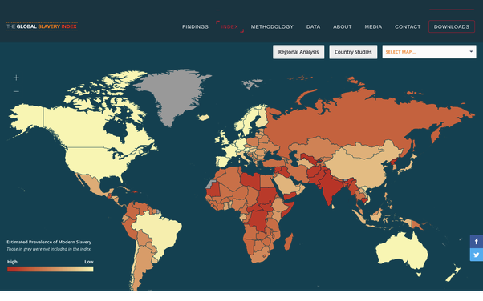

Atlantic Slave Trade
Slave imports to the America’s, 1451-1870

Region 1452-1600 1601-1700 1701-1810 1811-1870 totals

British
North America ------------ 30,000? 348,000 51,000 399,000

Spanish America 75,000 292,500 578,600 606,000 1,552,100

British
Caribbean -------- 263,700 1,401,300 --------- 1,665,000

French
Caribbean ------- 155,800 1,348,400 96,000 1,600,200

Dutch
Caribbean ------- 40,000 460,000 -------- 500,000

Danish
Caribbean ------- 4,000 24,000 -------- 28,000

Brazil 50,000 560,000 1,891,400 1,145,400 3,646,800

Old World 149,900 25,100 ---------- ----------- 175,000
---------------------------------------------------------------------------------------------------------
Totals 274,900 1,341,100 6,051,700 1,898,400 9,566,100

European in crossing the Atlantic had a death rate of 20% average

Slave in crossing the Atlantic had a death rate of 25% average

Dehydration, dysentery and Scurvy were the major causes.

Skilled craft workers
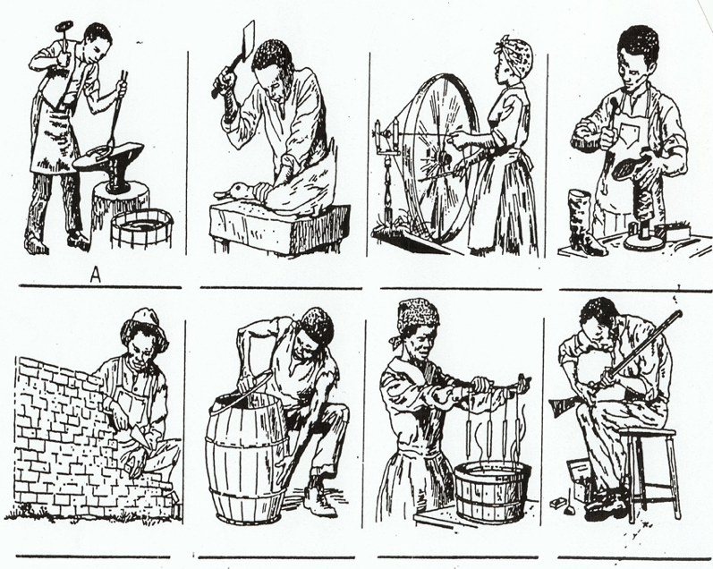

Spanish and Portuguese Slaves Trade
Slaves imports by region in Spanish America 1492-1865
Cuba - 702,000
Puerto Rico - 77,000
North America & Mexico - 6.8%
Mexico - 200,000
Caribbean - 42.2%
Venezuela - 121,000
Spanish America - 11.0%
Peru - 95,000
Brazil - Mines 38.1%
La Plata & Bolivia - 100,000
Chile - 6,000
Santo Domingo - 30,000
Columbia, Panama, and Ecuador - 200,000
Central America 21,000
Others - 1%

Publications:
* The Ordeal of Integration – or - Rituals of Blood / Orlando Patterson
* Lay My Burden Down: A Folk History of Slavery, B.A. Botkin, Chicago: University of
Chicago, Press 1945 – Federal Writers Project
* Silencing the Past: Power and Production of History: Michel-Rolph Trouillot – 1995
* Sailing to Freedom:, Edited by Timothy D. Walker, University of Massachusetts Press, 2021
10 essays

Tobacco – deplete soil over time – 1st cash crop and North America the main crop in upper South
Surplus slaves sold to Deep South by the Upper South after the Cotton Gin invented
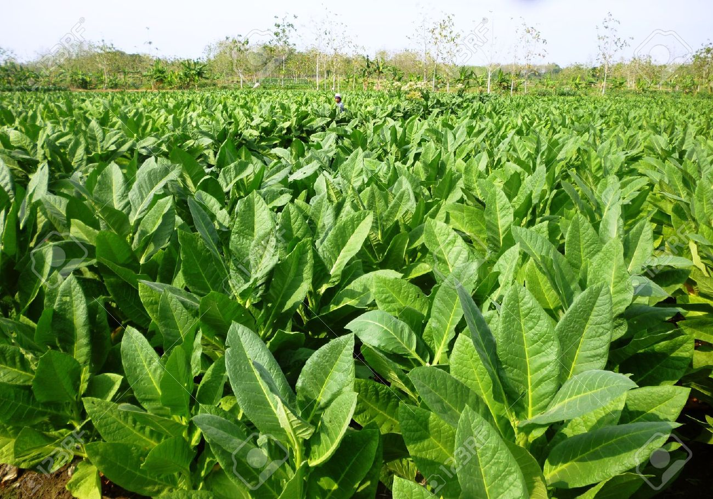

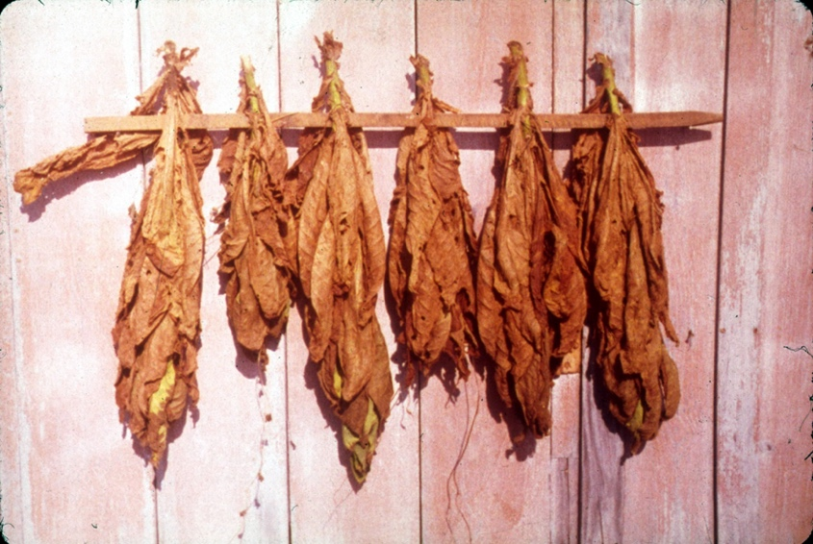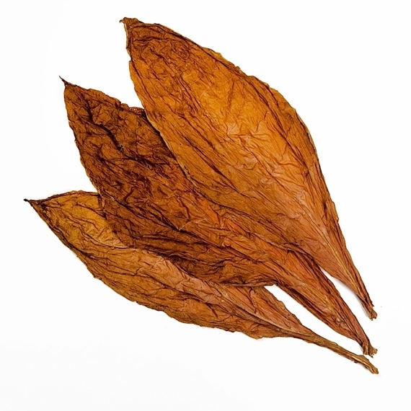

Drying Sheds
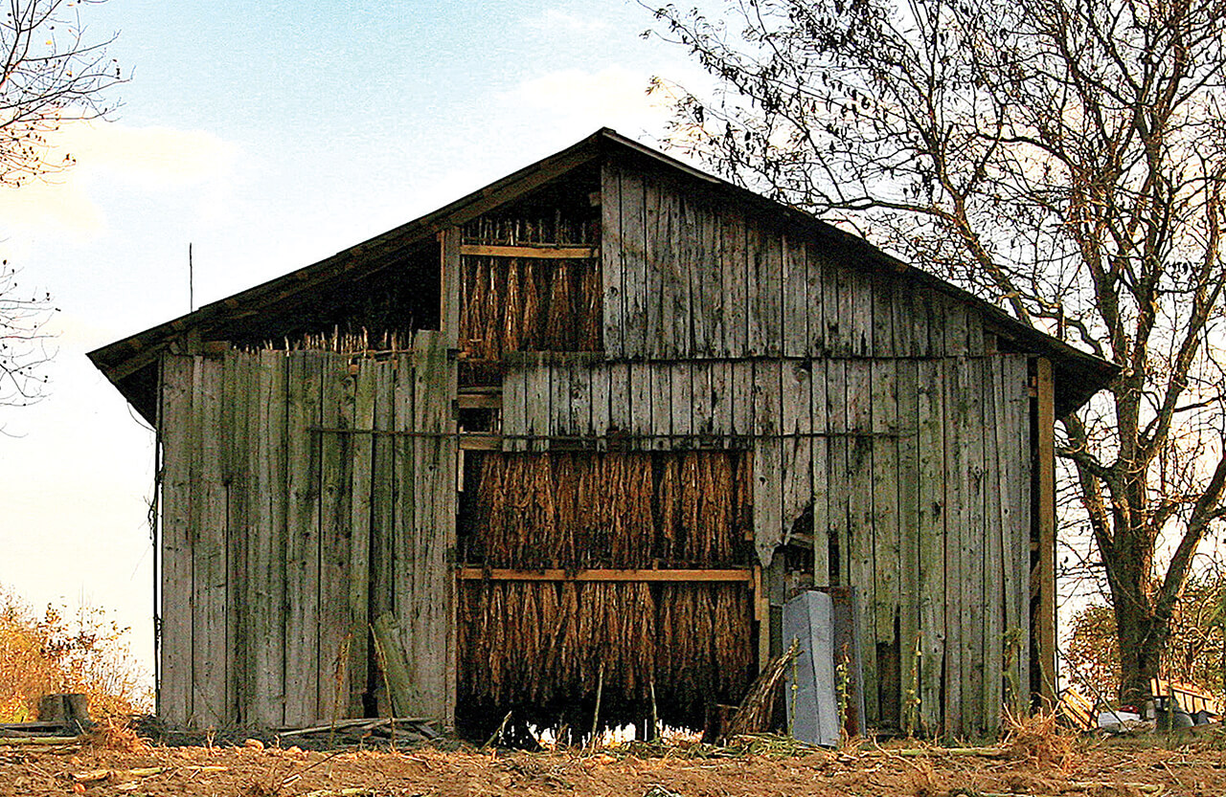

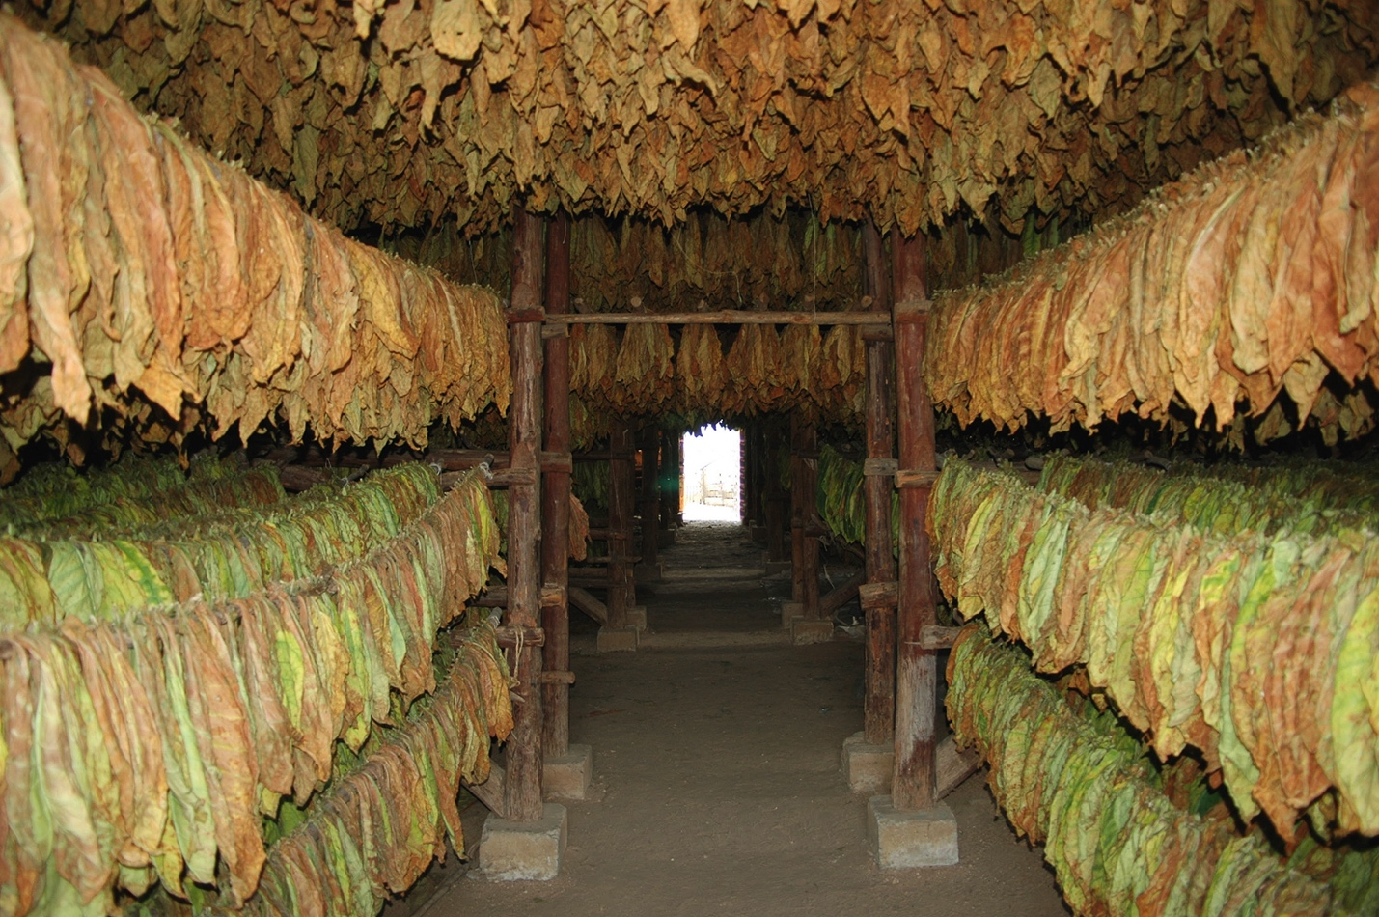
Cotton became profitable after 1992 with the development of the Cotton Gin
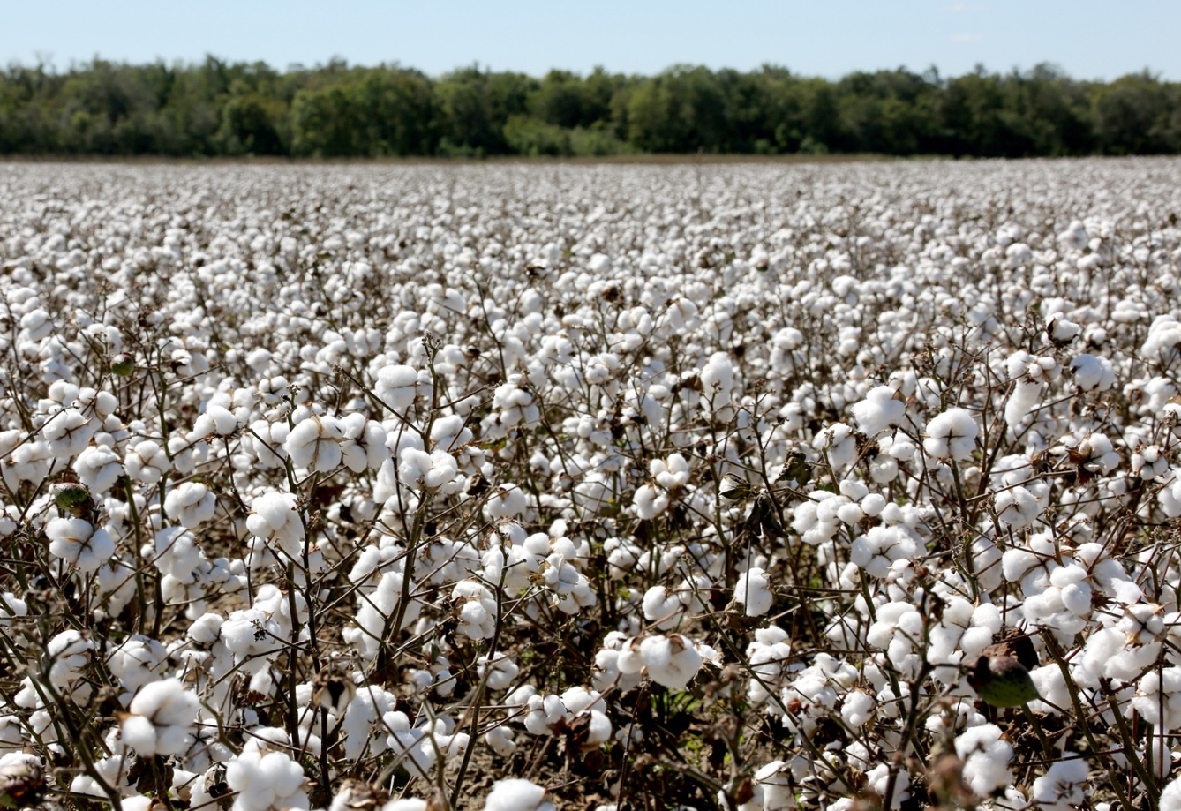
Back braking and hard on the fingers with cuts
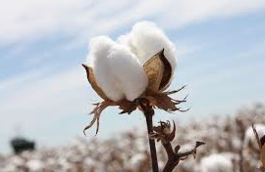
Cotton King
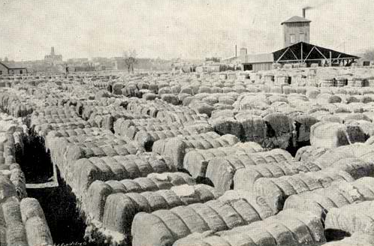

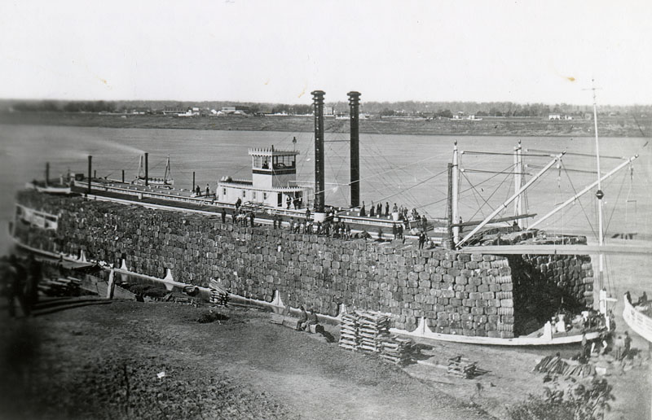

New notices in local papers
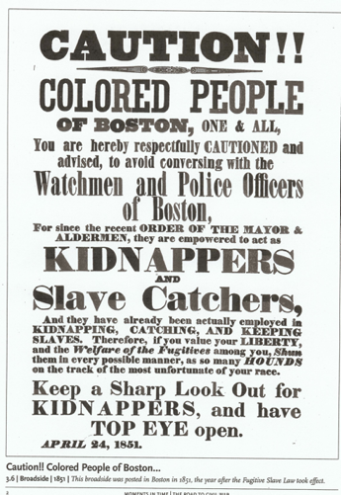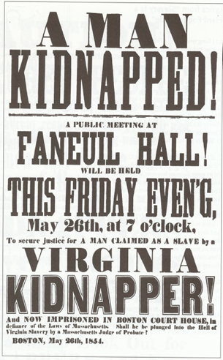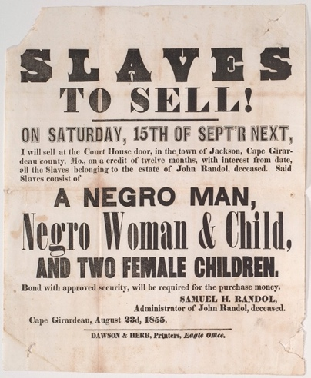
Navy
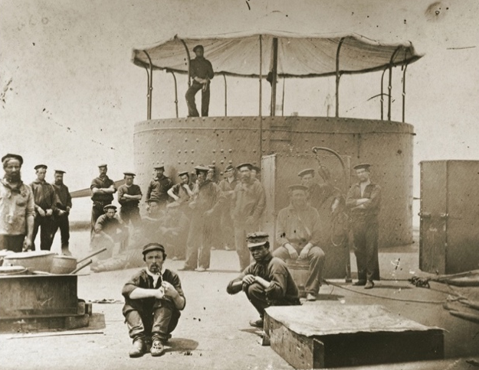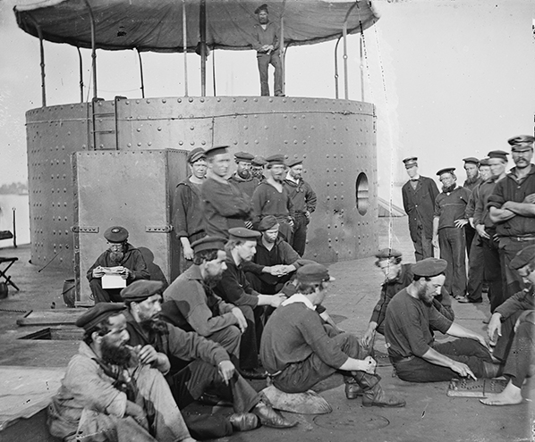
Black Sailor to the right
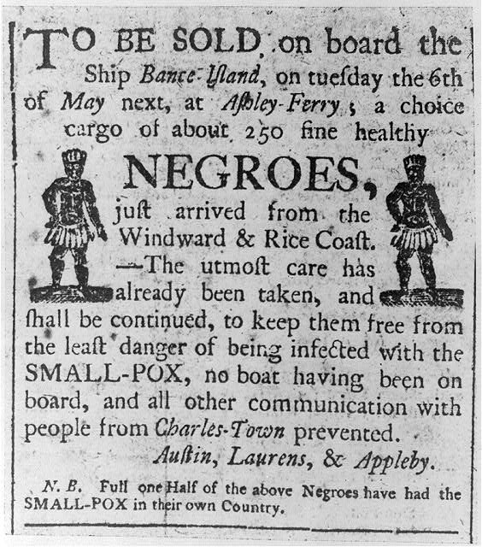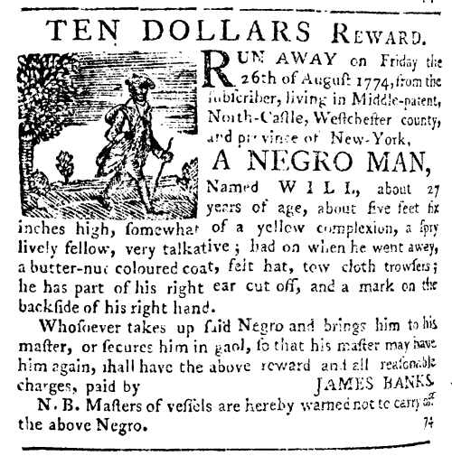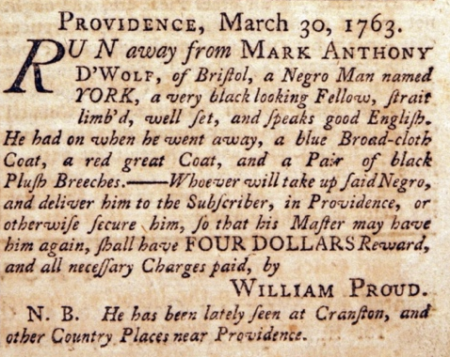

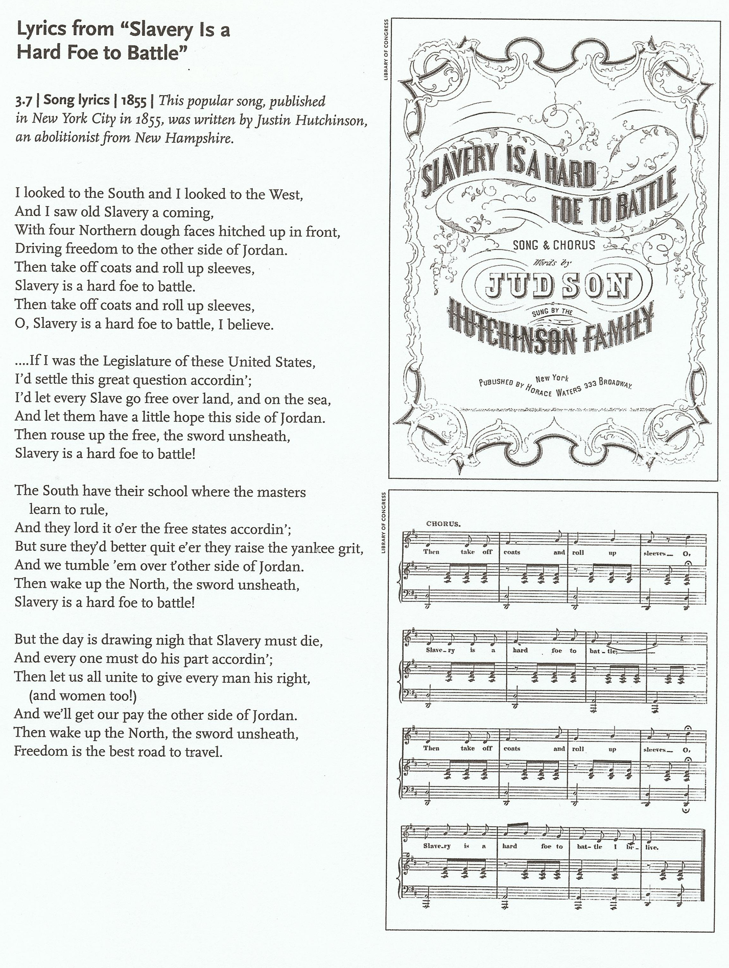

Lyrics to Blue-Tail Fly (Hidden Message within song)
When I was young, I used to wait
On the boss and give him his plate
And pass him the bottle when he got dry
And brush away the blue tail fly
Jimmy, crack corn and I don't care
Jimmy, crack corn and I don't care
Jimmy, crack corn and I don't care
My master's gone away
And When he would ride in the afternoon
I'd follow after, with a hickory broom
The pony being rather shy
When bitten by blue tail fly
Jimmy, crack corn and I don't care
Jimmy, crack corn and I don't care
Jimmy, crack corn and I don't care
My master's gone away
One day, he ride around the farm
The flies so numerous, they did swarm
One chanced to bite him on the thigh
The devil take the blue tail fly
Jimmy, crack corn and I don't care
Jimmy, crack corn and I don't care
Jimmy, crack corn and I don't care
My master's gone away
The pony run, he jumped, he pitch
He threw my master in the ditch
He died and the jury wondered why
The verdict was the blue tail fly
Jimmy, crack corn and I don't care
Jimmy, crack corn and I don't care
Jimmy, crack corn and I don't care
My master's gone away
They lay him under a 'simmon tree
His epitaph is there to see
"Beneath this stone, I'm forced to lie
Victim of the blue tail fly"
Jimmy, crack corn and I don't care
Jimmy, crack corn and I don't care
Jimmy, crack corn and I don't care
My master's gone away

Blue-Tail Fly and Hidden meaning
