World History #7
Egypt and the Nile Rive

5000-3100 B.C.E. King Menes unified Upper and Lower Egypt
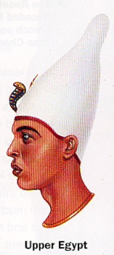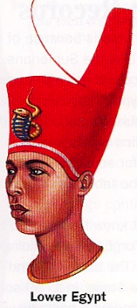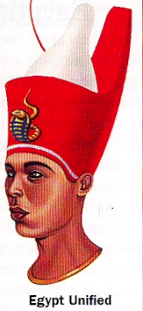

3100-2686 B.C.E. Archaic Period

2686-2181 B.C.E. Old Kingdom - Imhotep built Step Pyramid
Khufu (Cheops) & Great Pyramid could build a wall around France
10 feet high
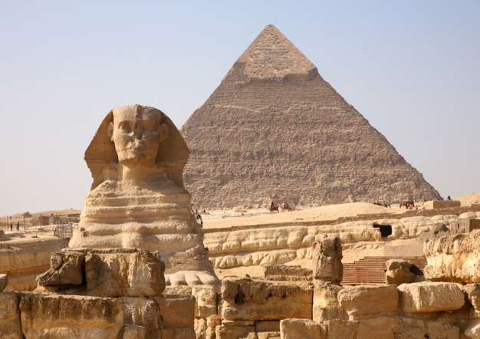
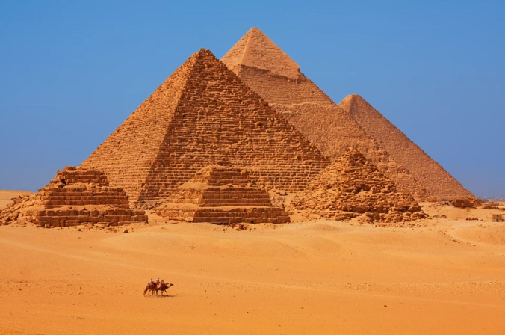

1650-1570 B.C.E. Hyksos invasion

1567-1085 B.C.E. New Kingdom

1503-1482 B.C.E. Queen Hatshepsut –

1379-1362 B.C.E. Amenhotep IV and a religious revolution to Amon-Re (Sun God)

1361-1352 B.C.E. Tutankhamen

1304-1237 B.C.E. Pharaoh Ramses II – the Exodus
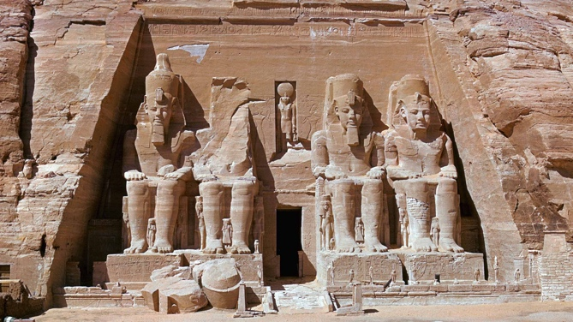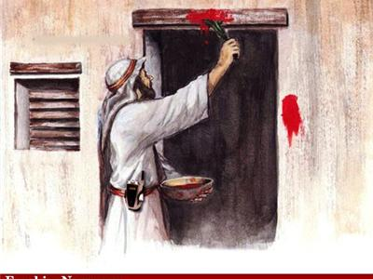
Passover

Egypt – hieroglyphics (hy-ruh-GLIF-iks) picture words papyrus flatten reeds 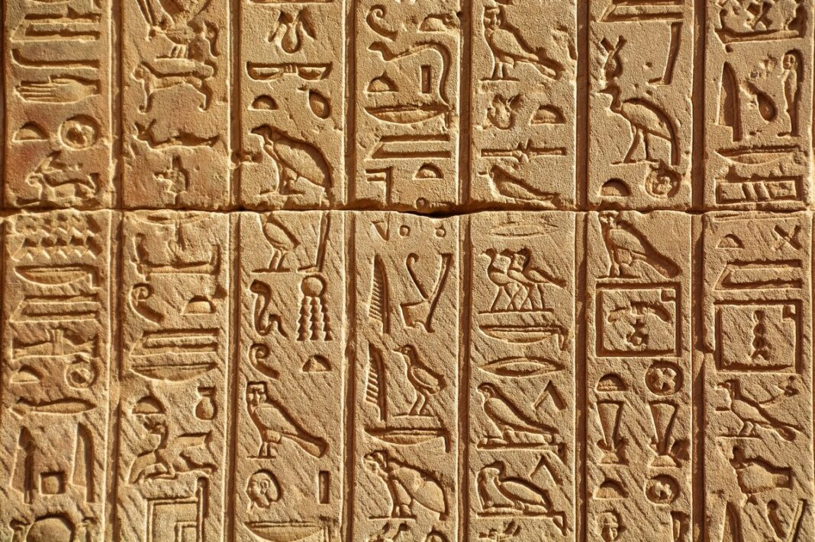 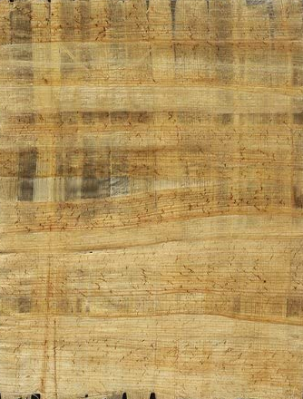
Egyptian class structure
Priests, commoners, and slaves
Because the Pharaoh was supreme ruler, no room for noble class
Had an elaborate bureaucracy of administrators and tax collectors
Had extensive professional military forces
Slavery existed on a limited scale and treatment was relatively humane
Same 3 categories described above: POWs, criminals, debtors

Symbolism in Egyptian art:
Tallest in art is the one with power
Hands to the side with shoulders square and left foot forward
People were identified by the color used: Brown = Egyptian
Black = from the South
Yellow = from the East
White = from the North
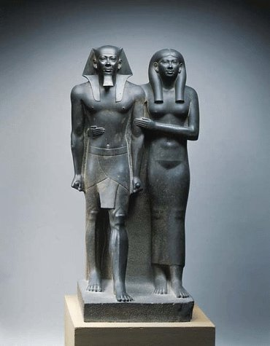
Left foot forward arms to the side – tallest most important
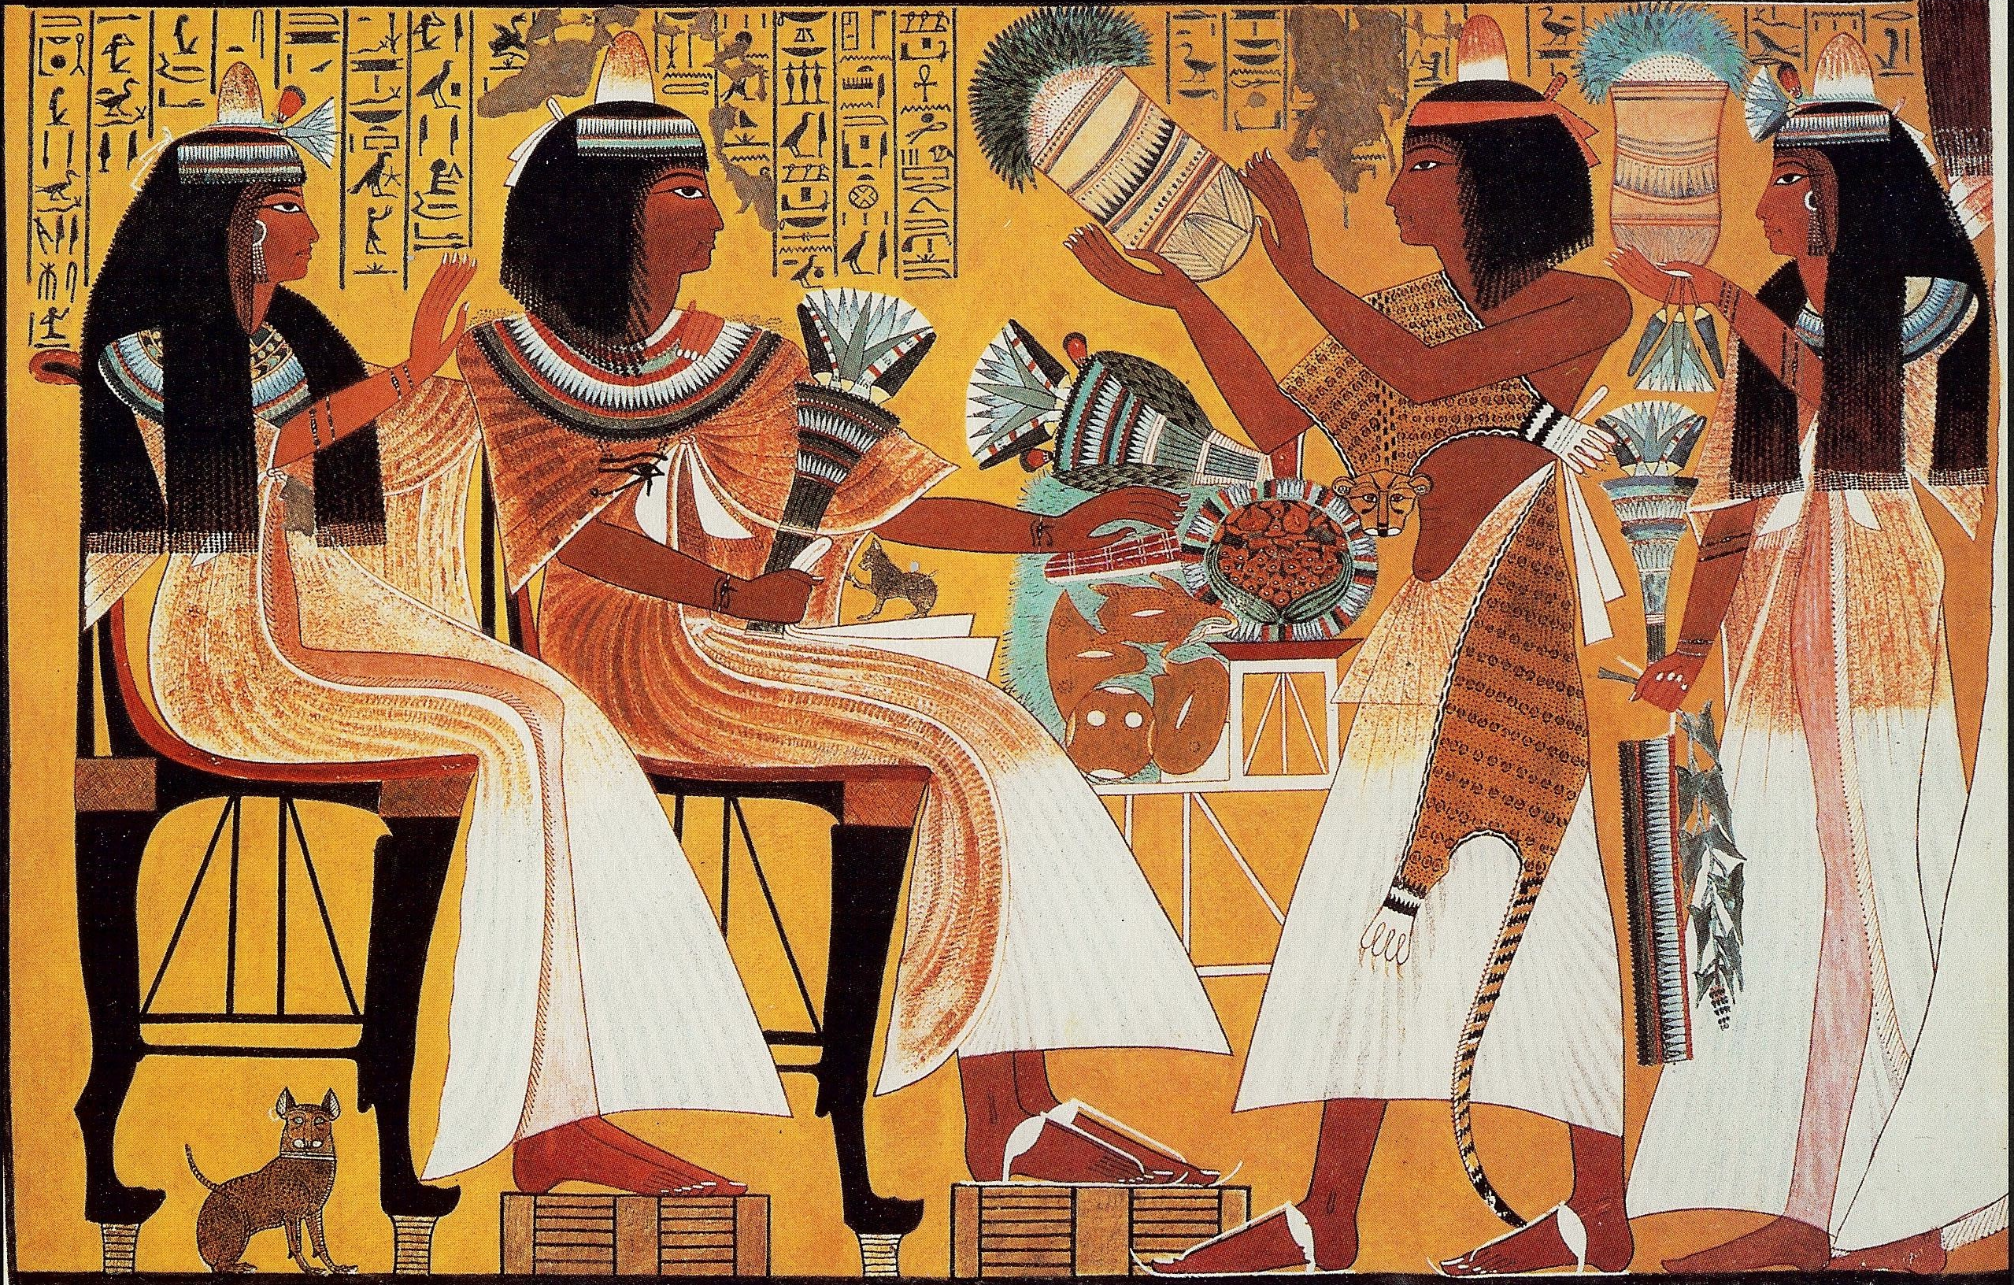

After Life
The dead soul spilt into two half’s one wandered and one stayed in the body. They would reunite if one passed through 12 chambers to reach “Duat” the Field of Reeds. To protect the soul in the body the body was mummified with the process of embalming that would leave only the heart in place.
To get through the 12 chambers one had to know the names of the guardians at each gate. The journey to the 12 chambers was across a river with a ferryman. To help the soul on the journey amulets and spells were left with the body. This idea was based on the myth of Osirian who was chopped into pieces and then put back together.

