World History #6
Mesopotamia (Land Between Two Rivers)

10,000 B.C.E. Last Ice Age - climate and diet change
Fertile Crescent
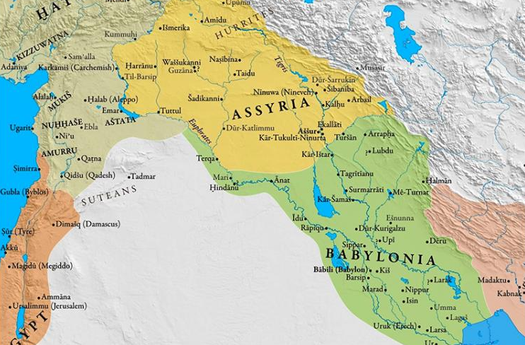
7,000 B.C.E. Agriculture started - Jarmo in middle east – rivers important
5,000 B.C.E. Mesopotamia – The land between Tigris and Euphrates Rivers
The Rivers were wild and flooded at different times
3200 B.C.E. Sumerians of Sumer
2700 B.C.E. Epic of Gilgamesh – story of a great flood
2234-2154 B.C.E. Sargon and Akkadians
2101-2004 B.C.E. Ur-Nammu the 3rd Dynasty / City of Ur
1792-1750 B.C.E. Babylon
1772 B.C.E. Code of Hammurabi – geometry
1750-1100 B.C.E. Myceneans traders in the Mediterranean Sea
1700-1200 B.C.E. Hittites Empire - developed iron
1700-1200 B.C.E. Assyrians – perfected use of iron and the Chariots Plus ruled by terror
1500 B.C.E. Aryan’s invaded India
1100-700 B.C.E. Classical Dark Age the collapse of the great Empires
722 B.C.E. Fall of Israel to the Assyrians
700 B.C.E. The Lydians begin to use coins
Phoenicians (fih-NISH-uh) sea traders and begin alphabet (purple dye)

626 B.C.E. Nebuchadnezzar
Hanging Gardens of Babylon
626-539 B.C.E. Chaldean Babylon Empire
586 B.C.E. Fall of Judah to the Babylon
567 B.C.E. Siddhartha Gautama is born (Buddha)
539 B.C.E. Persian Greatest Empire in Middle East - Cyrus II
Zoroastrianism (zor-oh-AS-tur) one god in struggle between good and evil

Mesopotamian society included:
Ruling and priestly elites
Free commoners
Mostly worked as peasant cultivators
Some in cities as workers or skilled people
Paid taxes
Dependent clients
Had no property
Wage laborers on farms
Owed a portion of their crops to owners (like sharecroppers)
Paid taxes
Slaves
3 main sources: POWs, convicted criminals, heavily indebted individuals
Most were domestic servants in wealthy households
Some were agricultural laborers
Many owners granted freedom after some number of years of good service
Some slaves were even allowed to trade and could earn their freedom
Sumerians, Babylon, Hittites, Assyrians, and Persians dominated the region at different times for the rivers were unreliable in their flooding pattern.

Proverbs from 2,000 B.C.
“Who possesses much silver maybe happy;
Who possesses much barley maybe happy;
But he who has nothing at all can sleep.”

“Into an open mouth, a fly enters”

“My wife is at the temple;
My mother is down by the river;
And here I am starving of hunger.”

“Wealth is hard to come by,
But poverty is always with us.”

“Friendship lasts a day
Family ties are forever.”

“Tell a lie. Then, if you tell the truth
It will be thought a lie.”

“For pleasure: marriage;
On his thinking it over; divorce.”
Cuneiform
Cuneiform – (Kyoo-nee-uh-form) wedge shaped
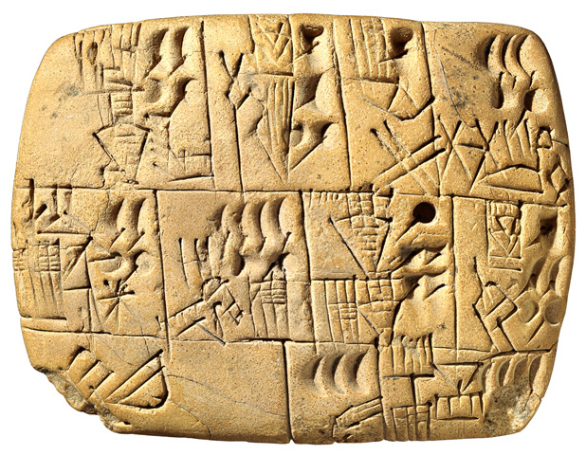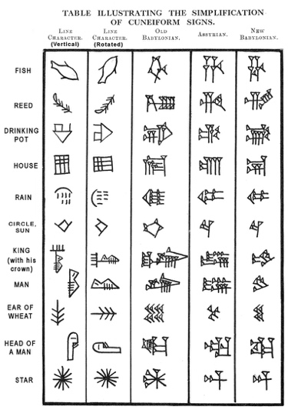

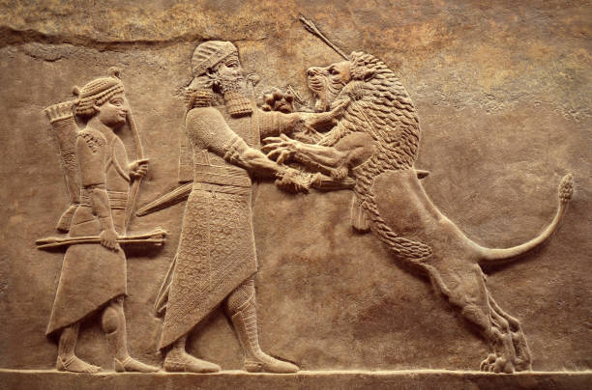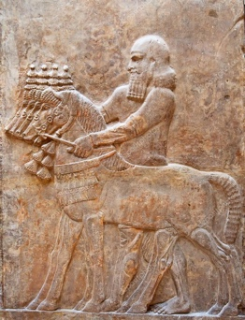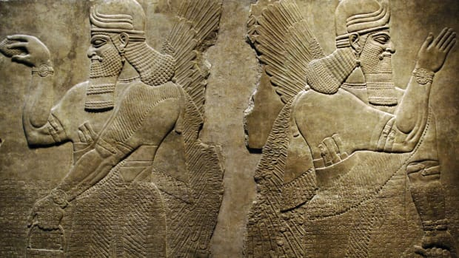
Art

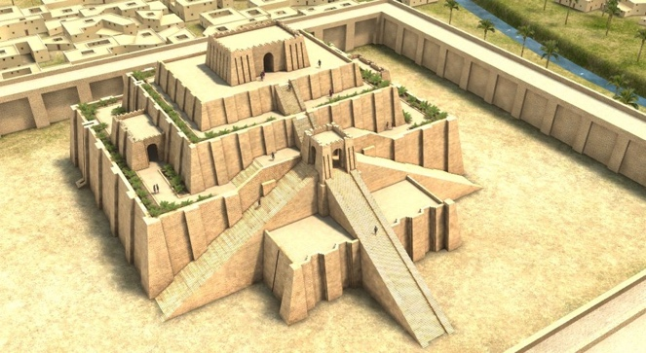
Ziggurat

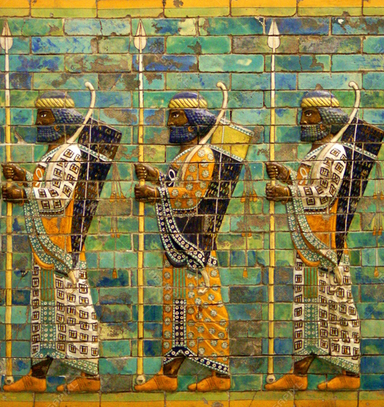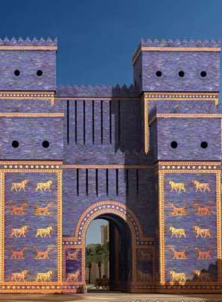
Archers Gate of Ishtar Babylon

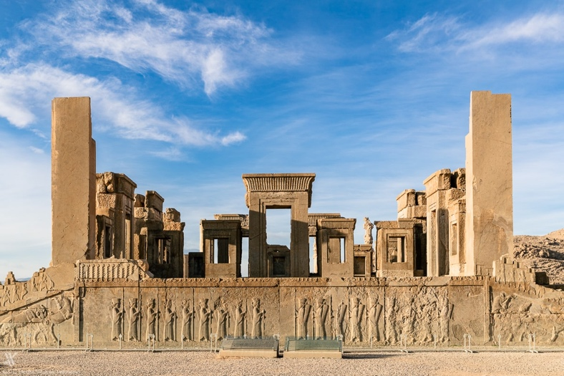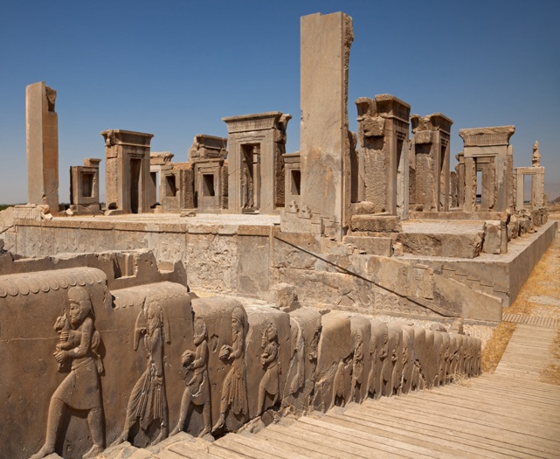
City of Persepolis – Persia

