World History #30
War of the Roses

House of Plantagenet

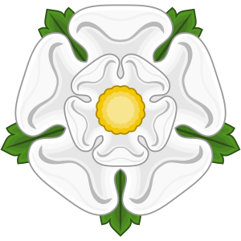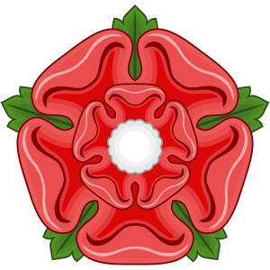
Lancastrians Yorkist

1422 Henry V died
1422 – 1461 Henry VI
1445 Henry VI married Margaret of Anjou
1453 Henry collapsed into a bout of insanity
Son born Edward in 1453
1453 – 1454 Duke of York (Richard) Lord Protector (Lancaster)
1455 Henry back and restored Margaret to power
1455 Duke of York took up arms at Battle of St. Albans with allies Neville, Duke of
Salisbury and Duke Warwick
Henry VI was capture and Duke Somerset was killed –
1459 Margaret gathered forces and resumed the war
Battle of Blore Heath in September
Rout at Ludford Bridge in October
Yorkist fled to Ireland and France
1460 Duke of Warwick defeated the Lancastrians at North Hampton
Henry VI was captured agreed that Duke of York’s son Edward would
become next King of England
1460 Margaret once more gathered forces and at the Battle of Wakefield killed the
Duke of York
1461 Battle of Mortimer Cross Edward York became King Edward IV
1464 Edward married Elizabeth Woodville
1467 Edward IV dismissed Warwick’s brother from office
1469 Warwick landed in Kent and Defeated the Kings forces capturing the King
1471 Edward IV return to England and defeated and killed Warwick at Barnet
Margaret was captured at the Battle of Tewkesbury
Henry VI was murder in the Tower of London
1475 Margaret was ransomed to France
1483 Richard III becomes King of England
1485 Henry Tudor defeated Richard III at Bosworth Field
1487 Henry II defeated Lambert Simnel at Battle of Stoke Field

The House of Tudor
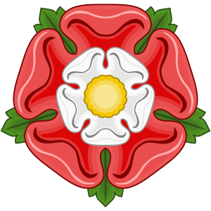

Results of the War of Roses

- Half of the Lords of England’s noble families were killed
- Increased the power of the Nobles
- Increased to political use of violence and assassination
- Reasserted the Crown’s power and superiority over the nobles

