World History #27
North America Before 1492

Native Americans before 1492 Early Native Americans were from Asia
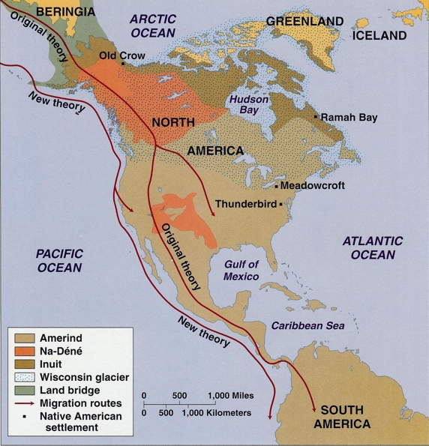
When did the arrive – Last Ice Age (Wisconsin Glacier) - Land Bridge
Bering Sea land bridge ended with the last Ice Age (Wisconsin) around 10,000 years. Cutting off the flow of people from Asia to the New World. There were four wave of migration. There are four basic language groups in the New World and the blood types are a result of this migration.
Native Americans (27,000 years ago) Four waves from Asia during the Last Ice Age (Wisconsin Glacier) – distinct lineages in DNA with 4 basic languages – No type (B)
Language Formed from four basic language groups that have:
200 sub-languages in North America + sign language
350 sub-languages in Central America
1,400 sub-languages in South America
*Note language is made up of:
8% words
37% sounds
55% body
*Native Americans spoke in ACTION not TIME as did the Europeans. Native Americans t language needed to have action and movement.
Example:
Native American speak in action:
What did they eat
Or
How did they eat
Europeans speak in time
We will eat
Or
They are eating at
Or
They ate at
Pre-Columbian Cultural Areas of New World
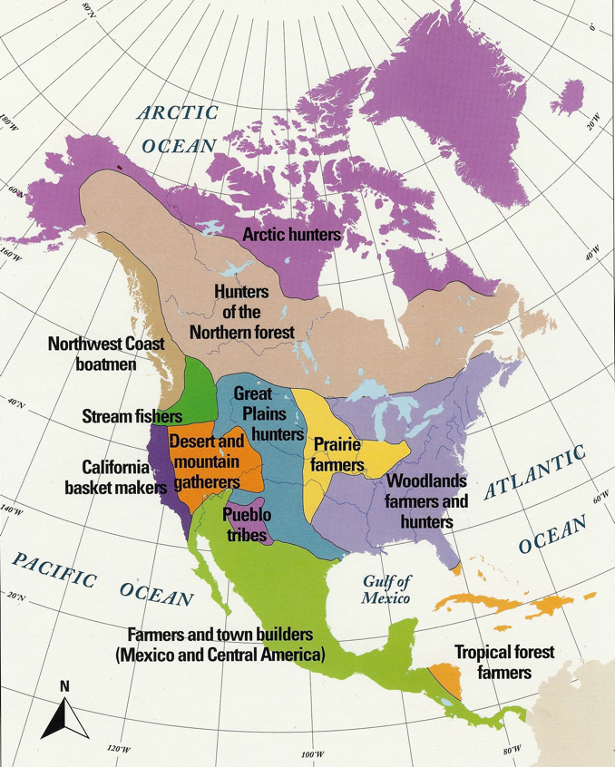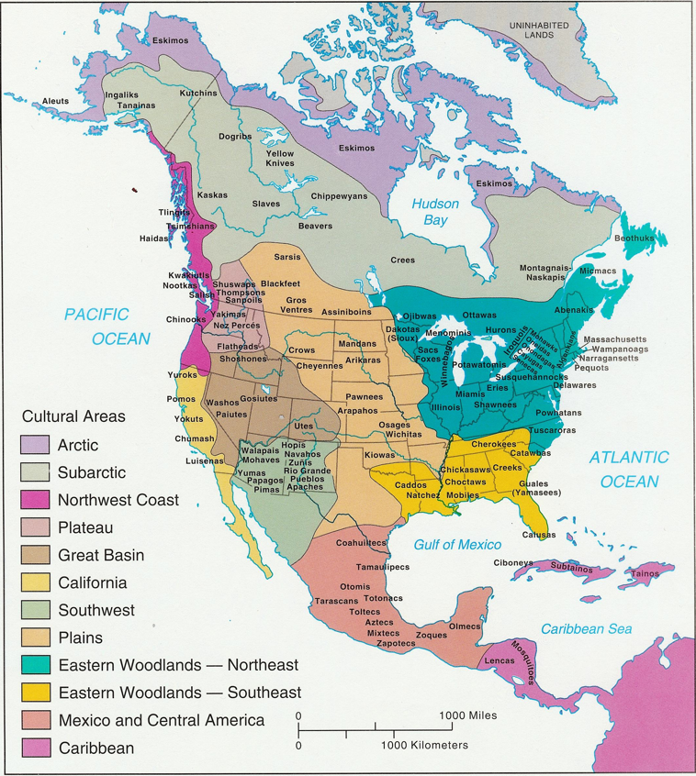

One mystery is the Kennewick man:
Bones were found on Columbian River in Washington State – he was found to be 11,500 years old and looked like the Ainu the original inhabitants of Japan – they still can be found in northern Japan today and look more European that Asian. Native American did not like this discovery.
Kennewick man found on Columbian River in Washington State – he was found to be 11,500 years old and looked like the Ainu the original inhabitants of Japan – they still can be found in northern Japan today and look more European that Asian. Native American did not like this discovery. The Native Americans were not victims of European colonization. They were opportunist that saw the European as leverage against other rivals for territory or to gain power. The Aztecs Empire were defeated by only Europeans warriors. Natives that were held under Aztec rule willing join the Europeans on the march to the Aztec capital. The Inca civilization ended with a civil war that the Europeans were a factor in which side won. Both of these Native empires collapsed when the central authority disappeared as a power base. The cities that had been the focal point for taxes cease to draw the local population to the city and were abandon.
Kennewick Man Ainu individual
They were in the Stone Age development in 1492
Early cultures
Polytheistic - Shamans would interpret the spirits and all things alive had a spirit
or good or bad – man was linked together
Earth was the Mother
Sun the Father
Hunter-gathers Trade was a means of ensuring goodwill (Gift Giving) was a give
and take society.
Kinship
Bands - Small tribes
Basket making started around 200A.D.
Agriculturalist
Slash and burn - Semi-sedimentary
Corn documented its own history 25,000 years ago and domesticated around
5,000 B.C.
Potato (food of the humble) with 5 or 6 varieties –today there are some 1,000
varieties – European believed it caused leprosy.
In 1744 Fredrick the Great order it grown for the poor. The Irish had it as main
diet with 1-14 pound per day until the Blight in 1845.
Leadership in North above Mexico was by authority and by Power in those below
Power is taken
Authority is given
North American plains native counted coup (striking the enemy) 1st to do give great honor
This made control of warfare difficult

Death in after life was a place one could revenge for wrongs in this life. Bodies were left damaged to make after life difficult.

Natives and reciprocal gift-giving – each party to give a gift back and forth – keep the peace

Bride purchased or stolen at time a ritual stealing

The Golden Age of North American Native population was past
In the South West:
Anasazi
Hohokam
Mogollon

In the North East:
Hopewell – mound builders

In the South East:
Mississippian
Cahokia
Natchez

