World History #26
New World 1492

Native American:
Came to the New World in four waves of migrations by a land bridge that ended some 10,000 years ago. The oldest archeology evidence of settlement in the new world is about 27,000 years ago and the date is found from Alaska to the tip of South America. The evidence for four waves of migration is that there are four basic language patterns in the Americas that divide into several thousand languages.
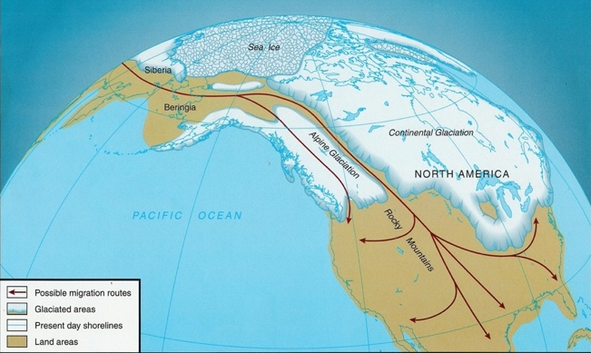
Yet, looking at the blood types one can see there was a progression of movement from the north to the south. Blood type “O” is common throughout the Americas followed by Blood type “A” into Canada and northwest with a few pocket in in the U.S. territory. There is an absent of Blood type “B”.
Blood Types of Native Americans before 1492 - Native Americans have one blood type “O”. There is some blood type “A” around the Alaska and a few pockets such as the (Black Foot or Black Feet). There was no blood type “B” in the Native American populations before 1492.
BLOOD TYPE “O” BLOOD TYPE “A”
“A” blood type in the Blackfoot/Blackfeet

BLOOD TYPE “B” (youngest)
None in the Americas

Asia
Native Americans – “land bridge” in 4 waves
*Pacific Islanders?
One can sail to America from Asia and almost never leave the sight of land. However, from Europe the same condition does not exist.
China: Compass invented – Cheng Ho sailed for the Ming dynasty in the early 1400’s with a fleet of 317 ships. The largest being 444 feet long and 180 feet wide with 9 mast.
In 1443 the leaders of China forbid the sailing from Chinese waters ending Chinese exploration.
There is also a theories for the settlement of the new world by ocean going explorations by early peoples. First, Pacific Islanders moved across the Pacific Ocean as far as Easter Island. Secondly, there are stories of Japanese and Chinese sailors off the west coast of North America. Finally, some have suggested that Africans seafarers reaching the Americas based on native artwork. Or maybe all types of arrival are right!
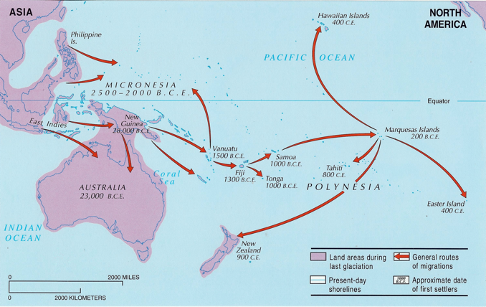
Pacific Claim Admiral Zheng’s claim

Who were the Red Paint People? Mystery 6,000 ago

Latin America before 1492
Mayans – Yucatan, Belize, Guatemala, El Salvador, and Honduras power gone by1492
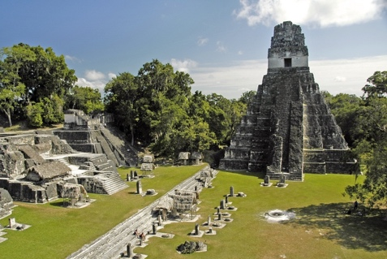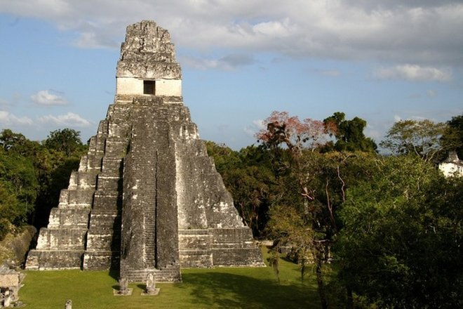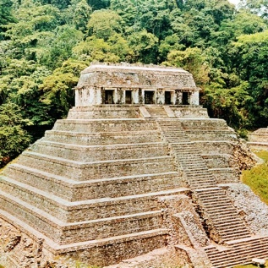

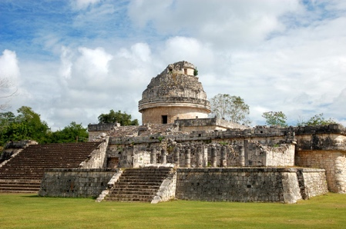
Caracol Observatory, Chichen Itza
- Calendars
a. Religious–260 days year in 20–13-day months with 5 at the end
b. Agricultural – 365 days – within .0002 of today’s calendar
- They had a numerical system with the zero in units of 20
- Pre-Classic period 1250-450 B.C.
- Late pre-classic 450-300 B.C. start of civilization
- Classic period 300 B.C. – 900 A.D.
- engineers
- Kukulkan (Koo-kool-KAHN) – Quetzalcoatl
- City-State authority Halach Uinic (hah-LAHCH-oo-ee-NEEK) Great Lord or True Man absolute hereditary ruler – 6-7 defined social classes – ritual core of city – pop (woven mat) symbol of royal authority – Tikal (tee=Kahl)
- Sky held by four trees on back of crocodile with 13 layers of heaven and 9 layers to underworld – smoke carried message to gods
- Largest temple El Mirador 55 meter high (180 feet) – El Castillo has 365 steps to the top
- Cross eyed was a beauty mark to help by dangling objects in front of babies eyes and front teeth filled with gems
- Abandoned cities between 850 – 900 A.D.
  - Warfare
  - Epidemics
  - Natural disaster
  - Invasion from outside
  - Over population
  - Over production of farm land
- Book on inside surface of bark - 800 picture graphs
14. Destroyed by priest later only after copied
Aztec – god called Quetzalcoatl – light skinned would return in year One
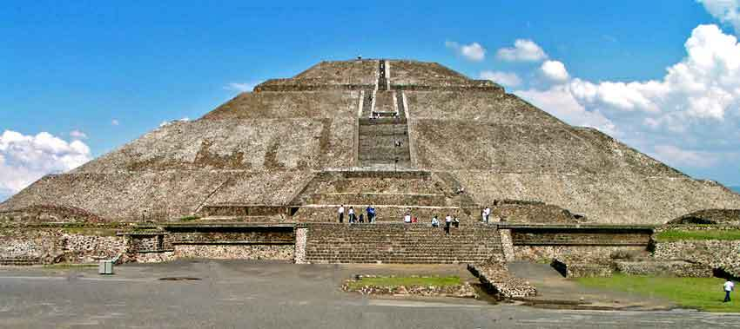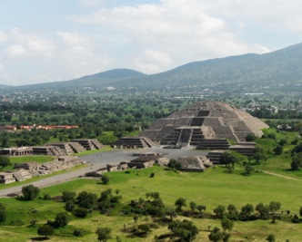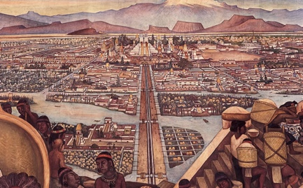
Organization of Empire:
- Controlled area by 1400’s – Lake Texcoco
- Did not try to absorb conquered into Aztec society
- Class or caste system
  - Emperor Priest as advisors
  - Nobles
  - Warriors
  - Ordinary free
  - Serfs
  - Slaves
- Tribute not colonization - blood
- Quetzalcoatl (ket-zeel-oe-POTCH-tlee) world destroyed 4 times and created 5 times in 52-year cycle
- Year Reed One – return from east (beard and light skinned)
- Tenochtitlan (tay-noch-teet-LAHN) capital
- King elected and was met face down – death to see his face
- King smoked before decisions – king could not overrule a judge
- Engineers who built canals, temples, hill terraces, irrigation systems, aqueducts, sewers, floating gardens and fountains
- Education highly valued – schooled until 15 boys and girls
- Religion some 63 gods – world shaped in five box like structure – world held together by blood – self-sacrifice in bleeding tongue and ears – higher the birth the more blood needed
- Tlaloc (TLAH-lok) god of rain
- Huitzilopochtli (WEET-zeel-oe-POTCH-tlee) god of Sun
- Sacrifice – Fire 1st day dance – 2nd day drugged – burned in pit and roasted – before death pulled out with hooks and heart cut out - blood needed – Pyramid of the Sun 235 feet high – 700 feet at base with 220 steps – dedicated with 80,000 lives – random terror may have been a method of control conquered
- Malinche (mah-LIN-tsin) Aztec noble woman sold into slavery – Cortes called her Dona Marina – she was good with languages that allowed Cortes to communicate with native populations that hated Aztecs

Conquest of the Aztecs
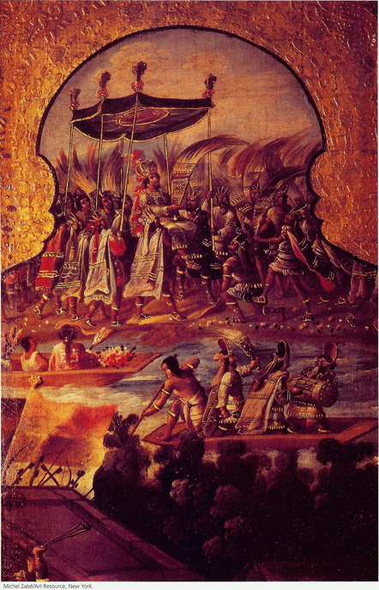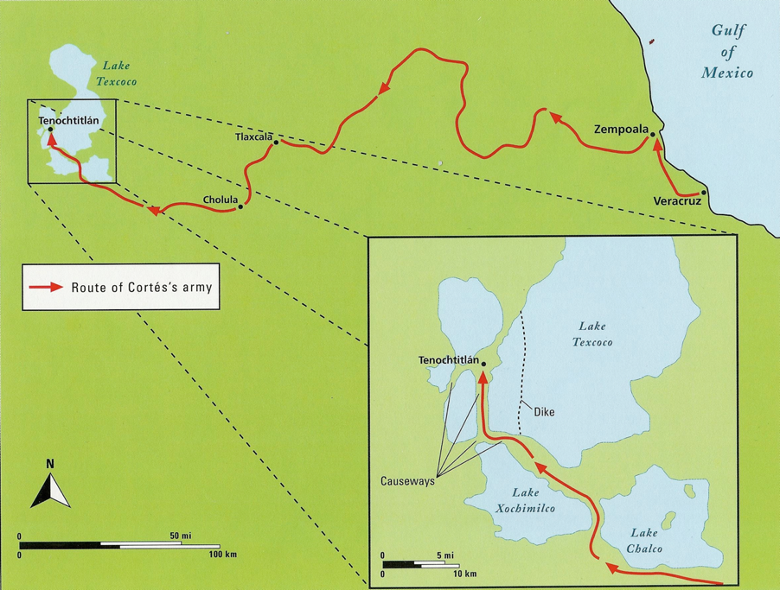

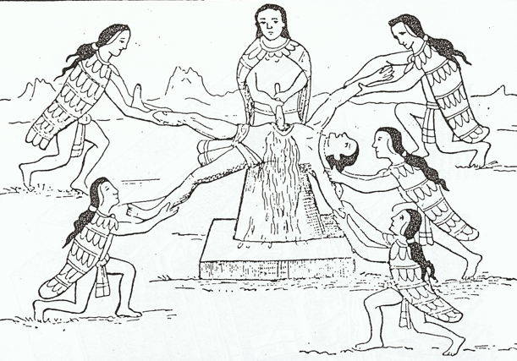
Hated by the groups they conquered willingly joined the Spaniards. The Aztecs conquered for tribute not land.
The human sacrifice horrified the Spaniards and set out to convert the heathens to Jesus hanging on a Cross. The Aztecs were horrified by the God nailed to the Cross.

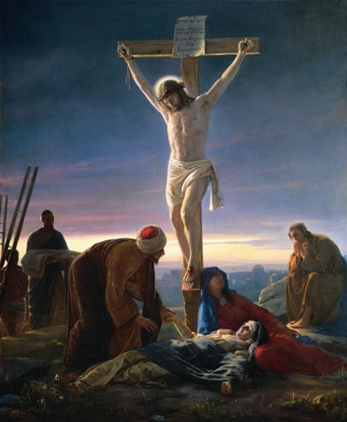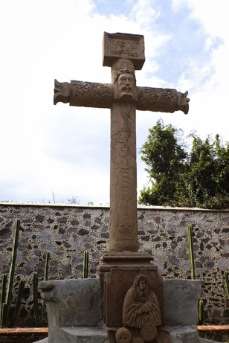
How to make Jesus on cross less barbaric?
Embedded Jesus into the cross rather than hanging on it.

Inca
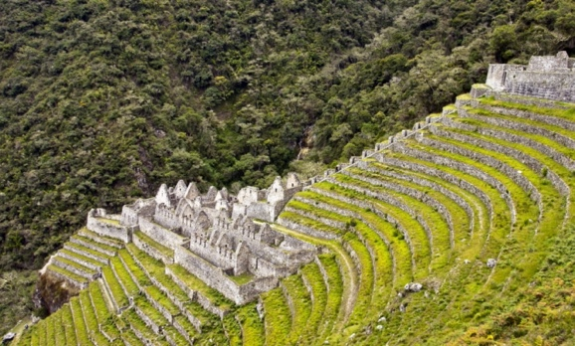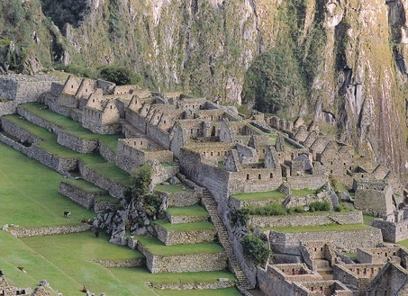

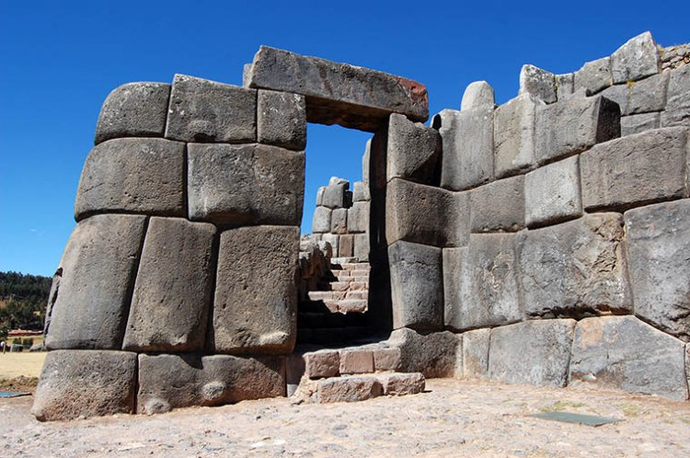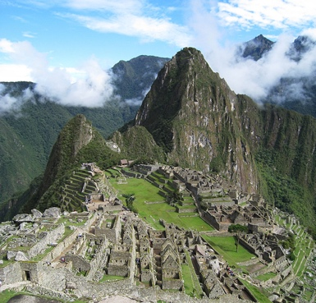
Periods
Archaic period 7000 – 2500 B.C.E.
Pre-classic 2500 – 1 C.E.
Classic 1- 1000
Post Classic 1000 - 1500
South America Civilization - Pachacuti first ruler or Inca 1438
A. Incas controlled area that included Chile, Peru, Ecuador, Bolivia, and Argentina by
1532 – 100 ethnic groups – 20 languages
B. Made the conquered into Inca’s in language and religion – resettle within empire to
control and spied on – not allowed to travel
C. Cities used to pay tax in labor – capital Cuzco (kOOZ-kuh) cities held small
permanent populations
D. Engineers built 55,000 miles of road and bridges – roads sweep clean every day – to
burn a bridge was death sentence – message could be carried 2,000 in seven days by
relay
E. Medical – doctors did brain surgery – if patient died doctor tied to him and left on
beach – coca used as pain killer
F. Had a public health system and inspections
G. Decimal system – calendar
H. Universe was a box world – Sun most important – temples walls covered in gold
I. Agriculture allow surplus
a. 300 varieties of corn
b. potatoes at 4,000 feet, corn at 2,500 feet, and cocoa at 800 feet
c. first to freeze dry food
J. The leader Atahualpa (AT-ah-wahl-puh) was taken by Pizarro
K. He then offered to fill a room 22 feet by 5 feet at the height that a man could reach
with gold and silver – 13,000 pond

