World History #25
Spanish Empire

Spain had a history of Iberian Peninsula:
Basques and Celts
Phoenicians
Greeks
Rome
Visigoths
Franks
Jews
Muslims – Arabs – Berbers – Moors – 711 A.D. to 1492

Reconquista - pushing the Moors out of Spain
Song of Roland story of war against Moors El Sid part of story

Surnames father’s name then mother’s – preference play’s a part Alvar Nunez Cabeza de Vaca – dropped the Nunez / Francisco Vazquez de Coronado y Luxan became Coronado
Or
Hernando de Soto became De Soto

1420 Portugal and Prince Henry the Navigator started the first national exploration to find
a southern route to the Far East with a new ship design the Caravel that sailed with
and against the wind.
1434 Gil Eannes and around Cape Bojador
1444 First African slaves to pay for trips

1469 Isabel of Castile married Fernando of Aragon
1492 Isabel gave Columbus the funds to explore a western way to China and India
New World and Columbian Exchange:
New Foods that double the food supply Corn (Maze) Potato and they grew were
wheat and rice did not
Population explosion
Jews Expelled from Spain
Jews moved to Portugal then Brazil then expelled and move with Netherland
(Dimond Trade)
Columbus used knowledge of currents and the Compass form China
Conquest – Three G’s (Gold, God and Glory)
Conquistadors (Warriors) what to do with them?
1494 Pope divided Atlantic between Spain and Portugal with Treaty of Tordesillas
1497 Amerigo Vespucci – a German map maker named Martin Waldseemuller and the
New World after Amerigo on his maps.
1519 Cortes landed in Mexico and marches on to the Aztec Empire at Lake Texcoco and
the city of Tenochtitlan
1532 Pizarro captured the Inca Chief Atahualpa who promised gold and silver
1533 Atahualpa murder after converting to the catholic faith
1554 Philp went to England and married Queen Mary who was eleven years older than
him. Thomas Wyatt had started a rebellion against the marriage of the English
Protestant Queen to a Catholic. Mary believed her half-sister was involved and had
her arrested and imprisoned. During this time Lady Jane Grey was Queen of
England for just nine days.
1559 Ottoman Turks recognized Spain control of southern Italy with the Treaty of Cateau-
Cambresis
1583 The end of the War of Portuguese Succession Spain controlled Portugal’s oversea
Territory until 1640 when Portugal re-established its independence.

The Spanish in the New World stayed close to the coast line in most of the time.

Riches of New World:
Spain had sent 1,577 ships to the New World and 1,217 returned to Spain with 222,392,287 pounds of goods (gold & Silver). This increase of bullion caused inflation at home and a lack of interest in the development in industry at home. This was an economic disaster for economic and government in Spain.
The bullion was a target for other nations and pirates. The English ship called “Sea Dogs” raided Spanish ship and in 1588 King Philip order Admiral Santa Cruz to develop a plan for ended this English problem. The mission failed.

Ships:
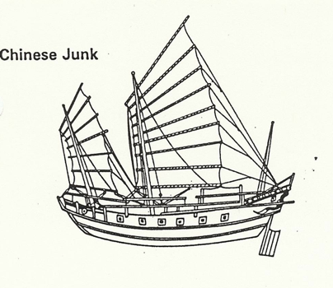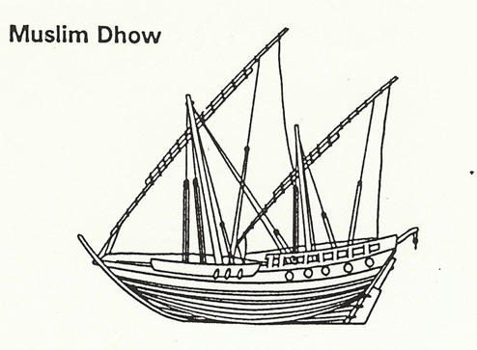

European Caravel took all forms of sails to allow for faster tacking into the wind
Prince Henry’s new ship The Spanish Galleon
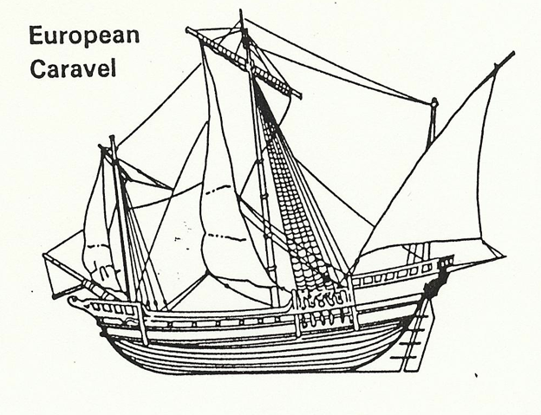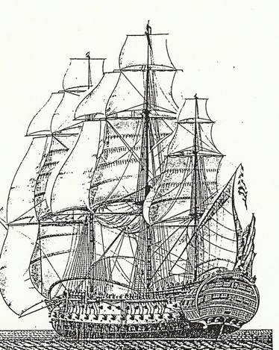
Made Tacking into the wind three times faster
The Conquistadors:
What to do with warriors who practiced the trade for 500 years. How to control their violent behavior? The New World was a solution. Many of these men had come from an area in Spain called the Extremadura. It was the poorest and most backwards area in Spain and was controlled by 11 families in 1434 and by 1934 controlled by 17 families.

All the conquistadors from Extremadura area were all poor by birth except Cortes.

Span as a World Hapsburg power:
Iberian Peninsula
Atlantic Islands
New World
Netherlands (Low Countries)
Naples and parts of Southern Italy
Sicily
Austria

