World History # 23
Kings

Time Lime:
800 Charlemagne Crowned King of Holy Roman Empire
1077 Road to Canossa obedience to Pope
1337-1453 Hundred Years War
1346 Battle of Crecy – English Victory
1356 Battle of Poitiers – English Victory
1415 Battle of Agincourt – English Victory
1412-1431 Joan of Arc
1453 Battle of Castillon
1455-1487 The War of the Roses
1492 Spanish Empire begins
1618-1648 Thirty Years War

The Holy Roman Empire and the Spanish Empire were built by marriage and the wars conducted were to maintain the Empire. The Church held the records and thus the power. Henry IV had a disagreed with Pope Gregory VII. Then King Henry had to walk through snow to Canossa to beg for forgiveness from the Pope.

The Roman Catholic Church held Europe unified under the church rule and the Pope. In western Europe the church and King were lose separate powers while in eastern Europe the church and king blended together into a stronger joint rule.

Control the Pope and control the church so in 13098 King Philip IV of France move Pope Clement V to Avignon for the next 67 years. At times there were 2 or three Pope’s claiming to be the authority of the Catholic Church. There were seven French Popes and 111 French Cardinals during the Babylonian Captivity period.

The Hundred Years War saw the English claim in France based on William of Normandy and his conquest of England in 1066. The three major battles of these war were won by English long bowmen. They were a real threat on the battle field. The French would cut the middle finger of any long bowman they captured. The long bowmen would show the French their middle finger before the battles. The English Black Prince and the young milk maid Joan of Arc became the subject of legends.

The last major battle of the Hundred Years War at Castillon was won with artillery that open the door for kings to become all powerful. Marriage in Spain allowed the force of Spain to join and remove the Moors for the Iberian peninsula in 1492. As Spain began to expand its Empire with riches form the New World.

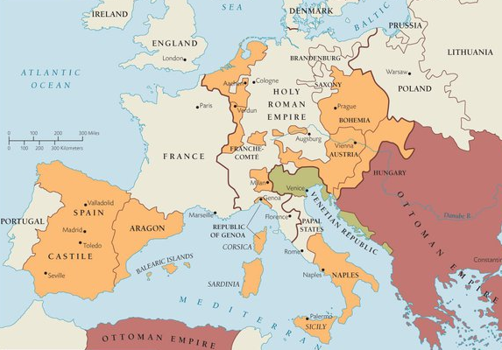

Who held the power and birth right began the War of Roses between the House of Lancaster (Red Rose) and the House of York (White Rose). The war ended with a marriage of Henry Tudor and Lancaster to Elizabeth a York.

In 1517 Martin Luther nailed 95 These to the Church door for discussion. The questions were printed out and circulated and became a wider discuss than just inside the church. The church of Roman was collecting funds from Germany to build the Vatican. The German northern Princes saw Luther as a way of keeping that money at home and offered protection. Everyone remember Jan Hus and his dissenter views.
The Reformation saw the church split and Kings made decisions of which faith their territory followed. The Thirty years wars began and was one of the bloodiest wars in European History. Germany suffered the most damage and loss of life with some one half its population gone.
In England King Henry VIII defended the church and then asked for an annulment form his wife and was refused. Sir Thomas More refused to accept the King as supreme authority in the church. More resigned from office and the King felt betrayed and had More arrested and tried for treason and executed in 1535. The King then order the Church out of England and confiscated church property and made the King of England the head of the church of England.
King Henry VIII went through six wives to conceive a male offspring – Edward, Mary and Elizabeth. The death of Henry VIII set of religious struggle within England. King Edward continued the Protestant church. At Edward’s death Mary became Queen and the Catholic Church was allowed back in England and Protestants were executed that gave Mary the tile of “Bloody Mary”. Queen Elizabeth came to power and the Protest Church was in full control of the country.

By 1638 the King of France became the “Sun King” with absolute authority over national issues. The Pope’s authority was set into church matters and secular matters to the Kings.

The Empires began to fall apart with rebellions and outside rivalry. Spain was forced to defend its Netherlands lands form rebellion and the new world shipments of gold and goods from English “Sea Dogs” after the marriage with Queen Mary fell off the table and Queen Elizabeth naval victory over the Spanish Armada in 1688.

Peasant rebellions were very common:
1493-1517 Bundschuh German Peasants rebellion
1514 Poor Conrad peasants in Wurttemberg rebellion
1515 Slovene peasants rebellion
1524-1525 German Peasant War
1524 Palatine Peasants rebellion

Times were changing and rebellions would turn into Revolution on larger scales.

