#2 World History
Stone Tools

Prehistory is the time before written records. Our knowledge of the period is from the study of geography, archeology sites, artifacts, and oral stories that link prehistory together.
- 10,000 BCE – The end of the Last Ice Age (Wisconsin Glacier)
- Land Bridge Closed to the Americas

Tools and Artifacts:
Fashioning Tool Standardization Tool
For long term use By custom and keep

The tool making debris is as important as the tools in collecting information of the past. Tools were being made around 2 million years ago and the making gives us important information. Looking at tools made 250,000 years ago show that tools that were being made from a Right-hand individual had a clockwise rotation and those by Left-hand individuals had a counter-clock rotation. These tools from this time period suggest that around 50% of the individuals were Left-handed as they pounded the stone into a desired shape.

- At Lake Turkan. 57% made by Right-handed
43% made by Left-handed

- At another site 56% made by Right-handed
44% made by Left-handed

- A in Spain 250,000 years ago
61% made by Right-handed
39% made by Left-handed

Early tools were made of Flint (in the West) and Quarts (in the East).
- Utilization of tools were used for the occasion (stick to probing or rocks to throw)
- Fashioning of tools were made for long term use
- Standardization of tools were made following custom (modern hammer)

At the end of the last Ice Age the big game animals such as the Mammoths began to disappear. Smaller tools of arrowheads and fishhooks began to be used for smaller prey.
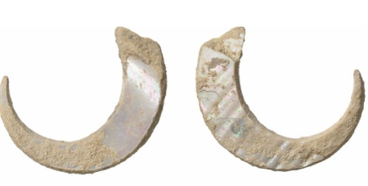

Fire was used by man around 500,000 BCE and this allowed man to digest complex carbohydrate making it was easier to get nutrition from proteins. This allowed better body and brain development.
The Human Brain starting around 250,000 years ago began a shift to a dominant Left hemisphere in brain function. Today only 10% of the population is Right-Brain (Left-handed). This shift has shaped how modern humans process information with the emphasis on logical order. Teaching has shifted to the Left-Brain processing information.
- The Left-Brain is logical and ordered in thinking
- Analytical -
- Methodical
- The Right-Brain is more creative and less order
- Artistic
- Creative
Early art:

