World History #16
Christian Church from Middle Ages
Western (Pope) Eastern (Patriarch)
Catholic Orthodox
Holy Trinity (1) Schism Holy Trinity (3)
Roman Catholic Church
Western Church of Rome
Pope
Cardinals – advisors (red)
Archbishop
Bishop – responsible for diocese
Monasteries – Abbot (Abbesses) Monk (Nun)
Hermit
Mystics
Johann Tauler 1300-1361
Heinrich Suso 1300-1366
Inward religious experience way to greater knowledge of God – distrust rituals
Jan van Ruysbroeck 1293-1381
Living ascetic and meditative life with evangelical devotion to reform
Catherine of Siena 1347-1380
Meditation and prayer – scourging self with iron chain
Seven Sacraments
- Mass and Transubstantiation (Bread & wine = flesh & blood of Jesus)
2. Penance
3. Confirmation
4. Baptism
5. Ordination
6. Eucharist
7. Marriage – not recognized by church in the beginning
a. Simple ceremony – kiss and rings exchanged with verbal promise
b. Priest not necessary
c. females 13-16 years old
d. males 20-28 years old rural and 30-35 for urban
e. Green for purity
f. barefoot for fidelity
Saints
St. Benedict – rule for monks/ vows of poverty, obedience and chastity
St. Augustine of Canterbury England
St. Patrick of Ireland
St. Dominic – walked barefoot across Europe / Dominicans = Black robe / Inquisition
St. Francis of Assisi – Grey
St. Ignatius Loyola = Jesuits – brown
St. Columbian in 600 A.D. prescribed 6 lashes for a monk who forgot to say amen. Ten
lashes for One that notched a table with his knife and 6 lashes
for on who sang out of tune.

Heresy – against teachings of the Church
Peter Waldo 1170 (Waldenisans)
Albigensian’s of Southern France
John Hus 1370-1415 (Prague) Used patriotism against Pope
Four Articles of Hussites
- Sacraments given by God to all men not just the clergy
- Freedom of preaching
- Remove clergy from temporal activities
- Clergy subject to civil law
- Lollards – England
John Wyclif 1320-1384 England He attacks on corruption and abuse – called Pope an
antichrist and Bible source of authority and called for the Bible to be in vernacular language of native country instead of Latin.
Excommunication = out of churches protection
To be an “outlaw” was to be outside the Law and anyone could kill the “outlaw”
Bastard was to be illegitimate child without protection of family
Interdict = Papal order to close churches in a particular country
Papal Bull’s – decrees by Pope
Exsurge Domine Bull issued 15 June 1520 held 41 censures of Martin Luther’s 95 Theses and threaten him with excommunication
Power
The Church held power by keeping written records of births and marriages (Law)
Church leaders were of Noble birth
Justice (Nobles) the gown is a symbol of old church power
Court seldom heard evidence – recorded statements did not examine witness
high justice – criminal
low justice – civil side
The killing of a bishop was 40 times greater than killing of a peasant
God’s protection:
By Battle by Ordeal God on side of winner
By Ordeals in Law God would protect the innocence
- hot iron – carry several paces
- hot water – pluck a stone out of a boiling pail of water
after each hand bound for three days – if infection – guilty
- cold water – tied hand and foot – if floated – guilty / water refused any evil (holy water)
Crusades called for by Pope Urban
1099 A.D. First Crusade called by Pope Urban
2nd Crusade – Saladin united Egyptians and Syria
3rd Crusade King Richard the Lion heart – allowed pilgrims to Jerusalem 1187
4th Crusade – sacked Constantinople 1204-1311
Holy Orders: Crusaders were warrior pilgrims and the Templers were warrior monks

Templars = White field with Red Cross
The Templars were the 1st international banker then in 1307 King Philip IV of France and Pope Clement V order arrest of order for heresy. Wealth and power threaten power structure and 54 members burned alive in one day. The Grand Master Jacques de Molay burned in 1314 and curse king and pope and both died within a year.
Hospitallers = Black cross on white field took care of those on the battlefield
Teutonic = White cross on black field – Germanic
Knights in war were uncontrolled – all wanted to agree on battle plans and did not follow orders

Truce of God
Forbade fighting from Thursday evening until Monday morning at Easter

Peace of God
Forbidden acts – enter church by force, plunder peasants attack on farmers, traders
Popes:
Pope Clement VI elected in Avignon - The invasion of Italy set off the idea of Contract Theory with idea of a fusion of mutual rights and Private rights
Pope Innocent VIII 1482-1492 had his son married to daughter of Lorenzo de Medici and
promoted his nephew to a Cardinal – who later became Pope Leo X
Pope Alexander VI 1492-1503 – his son was Cesare Borgia
Pope Julius II 1503-1513 (Warrior Pope)
Aristotle and Plato influence once more:
Plato to Neo-Plato
- emphasis on soul and reality – Transcending life beyond death – immortality of soul primacy to mind and contemplation – soul transcended body proof of God’s existence
- Truth outside church – individual worth / mathematics
Erasmus
Humanism – man created in Gods image
In the South - classical Greek and Roman grammar and rhetoric (Cicero and Law)
In the North – scriptures
Renaissance – money flows into Mediterranean cities – Reason and faith
Reformation – Schism / Catholic and Protesters
Counter-Reformation – Church response to Reformation – Faith and reason

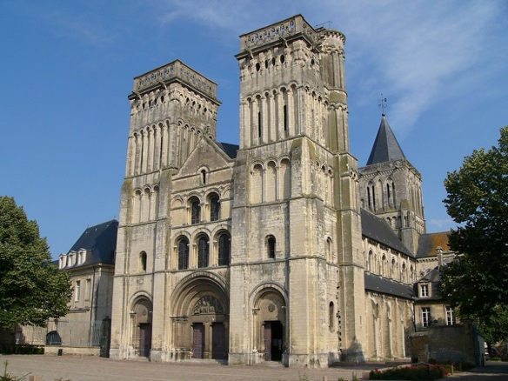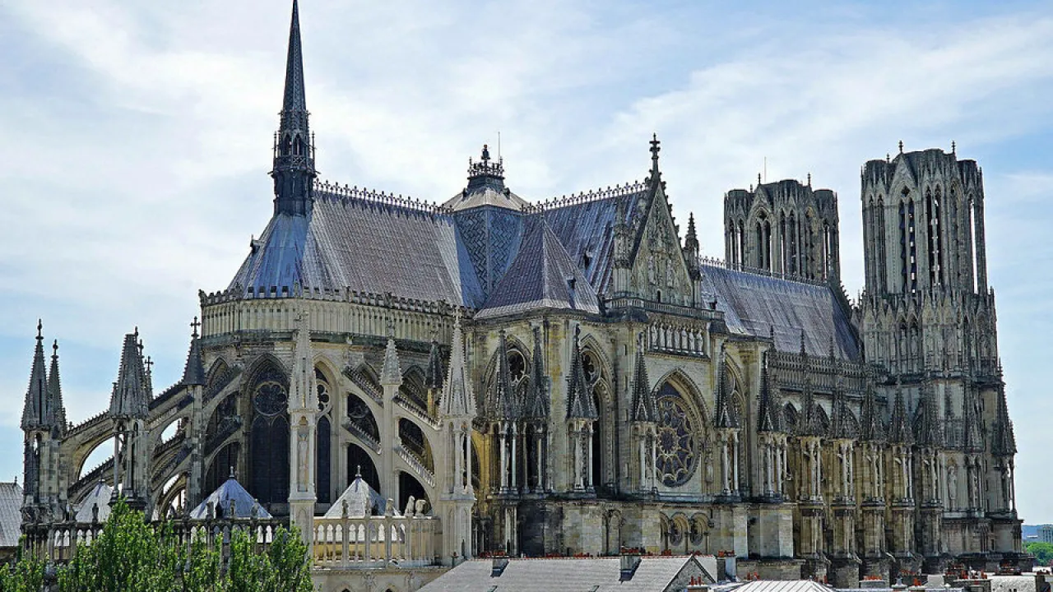
Romanesque Cathedral Gothic Cathedral

Eastern Orthodox Church

Is not directed from one individual but rather Councils to Keep the Faith. There are many communities of the Orthodox Churches – Greek, Russian, Ukrainian, Georgian, Armenian, and Coptic to name a few.

Ecclesiology = nature and structure of the church
Patriarch of Constantinople
Patriarch = of an ethnic / group
Archbishop = head of Country
Metropolitan = head of a City
Bishop = head of a Diocese
Titular Bishop = an assistant (Honorary appointment)
Priest = supervisory of group
Deacons = servant of church

Synod = advisory council (from Book of Acts) Apostolic Council of Jerusalem

Conciliarity = to get along in good favor and reduce hostility (Back-and-Fourth)

Greek Church Russian Church
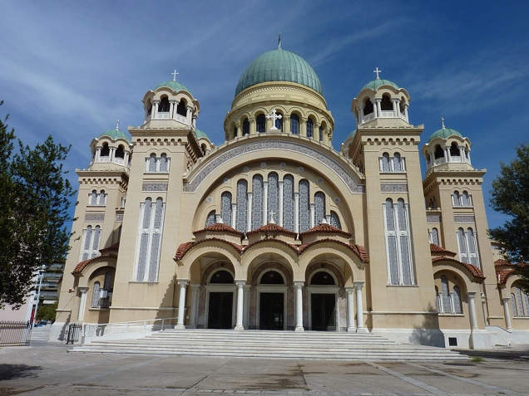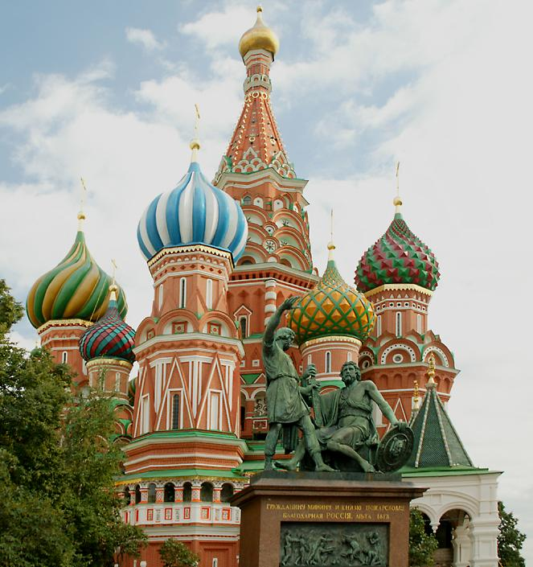

Icons
