World History #14
Jewish History

City of Ur – Abraham
Promise Land of Canaan
12 Tribes (families)
Famine forced Israelites to move into Egypt for 600 years until 1300 B.C.
Joseph’s Story
Moses and the 10 Commandments from Mount Sinai
Torah 1025 B.C. Kingdom of Israel
King Saul
King David
King Solomon with Solomon’s death the kingdom split Judah in south
750 B.C. Assyrians
586 B.C. Babylonians – captivity (Diaspora)
Torah, Psalms written into Bible
538 B.C. Many returned
Messiah = deliverer in Hebrew
66-73 A.D. First Jewish Revolt against Romans
73-74 A.D. Siege of Masada
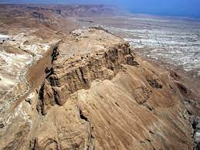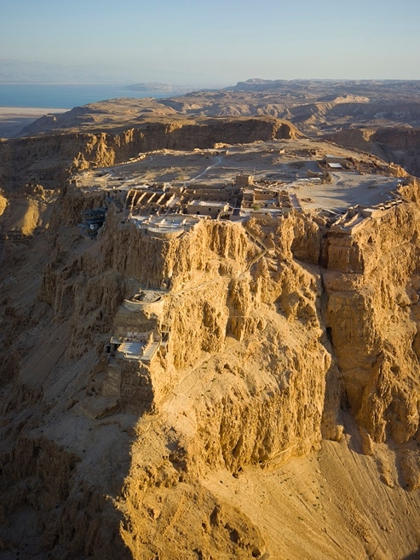
There were no survivors when the Romans enter the fort they called it the Citadel of Death. The last survivors then drew lot to kill each other.

100 A.D. More Jews lived outside of Palestine then in Palestine
115-117 A.D. Kitos Revolt
132-135 A.D. Bar Kokhba Revolt
1099 First Crusade slaughter Muslims and Jews

