World History #13
Rome Empire

48 B.C. Caesar - "I came - I saw - I conquer" “Veni, Vidi, Vici”
Cleopatra of Egypt
Mark Antony
Marcus Brutus
He won a civil war and instituted reforms
44 B.C. Caesar Ides of March (15) “You too, child” “You too, Brutus”

Octavian and Second Triumvirate
Empire divided between West and East
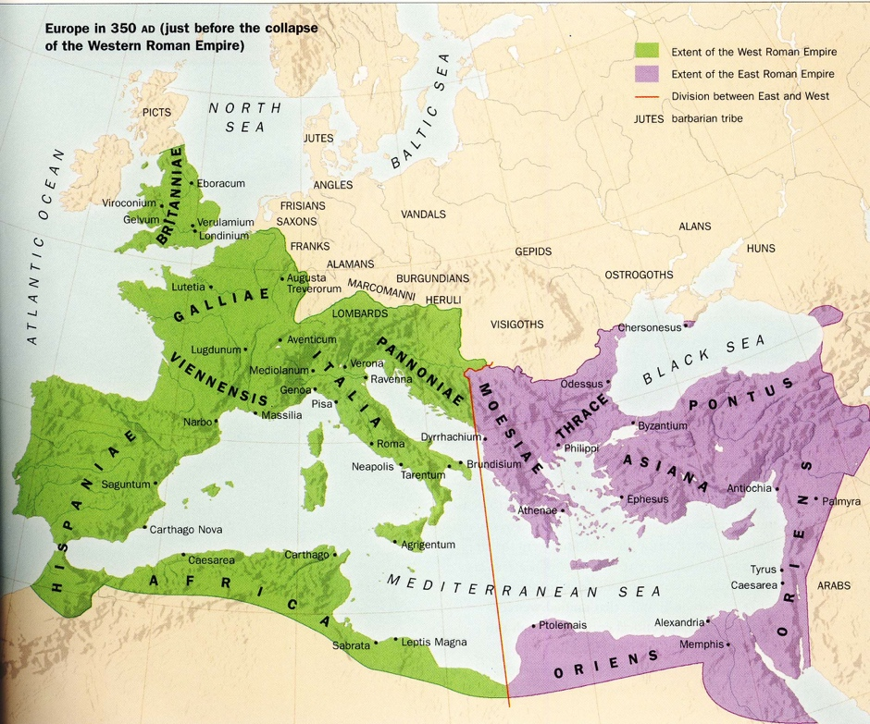
Early Christian’s & Paul - changed from Jewish sect to a new religion
Christian Church legalized
Judaism – Old Testament & Torah – Hebrew
Christianity – New Testament - Translated to Latin
All cities had a Pope – Rome became more powerful in West
Cardinals, Archbishops, Bishops, Priests, Monks and Nuns

In the East the Byzantine Empire with head of Church called Patriarch
Byzantine in east - civilization
Schism (split) Holy Trinity? (3 or 1)
330 A.D. Greek Orthodox (Greek) east (Byzantine) - split of Christian Church Catholic in west

Germans & Barbarians
387 B.C. Gaul (later called the Franks) – sacked Rome (France)
Angles
Saxons
378 A.D. Visigoths – enter Rome, Gaul, & Spain
455 A.D. Vandals – enter Gaul, Spain, Rome & North Africa-They sack Rome they are
remember today
452 A.D. Huns – from steppes – non-German Attila stop at gates of Rome by the Pope
476 A.D. Ostrogoths – enter Rome
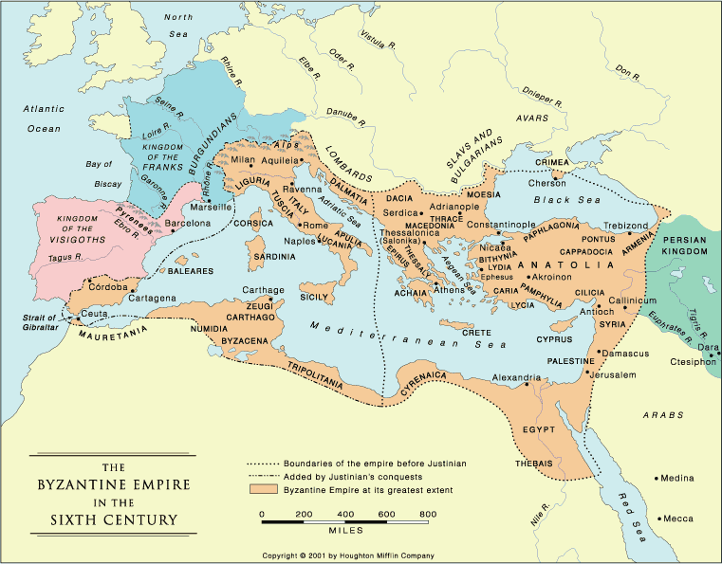

Fall of Rome – possible reasons:
Soldiers tied to general not the Senate
Collapse from within
Lead pipes – Poisoning
Outside forces - Germans
Great Wall of China – force nomads west in chain reaction
Decline of centralized government
Too large to control? – split into two parts

Western Empire fell in 476 A.D.
Byzantine fell in 1453

Cicero: (106-43 B.C.)
Cicero had sense of the world, whereas the Greek’s saw the polis (city-state).
The Greek’s saw superior and inferior groups, while Cicero said
“There is no human being of any race who, if he can find a guide, cannot attain to virtue.”
The principles of government were the process to good government for the Greeks. Cicero had a more practical base for good government. That of the state as a community of laws
“We cannot agree to equalize man’s wealth, and equality of innate ability is impossible, the legal rights at least of those who are citizens of the same commonwealth ought to be equal.”

Rule of law
True law is right reason in government with nature” the task is to discover the “nature of things” in a given situation and not impose a preconceived solution.
Man has common reason and must also have a common conception of law and justice.
While the Greeks saw man as social animal and that the state was the ultimate development of that need. Cicero saw mans love for man was foundation for government and law.
“Our natural inclination to love our fellow man.”
“Liberty has not dwelling-place in any state except that in which the people’s power is the greatest, and surely nothing can be sweeter than liberty; but if it is not the same for all, it does not deserve the name of liberty.”
It is Cicero’s rule of law and his populous that has had influence in our constitution.

Rome had no common descent, common language, or common religion Empire held together by Law. “We the people” and no man is above the law

Rome Art
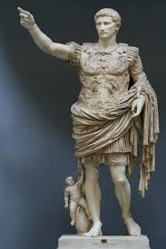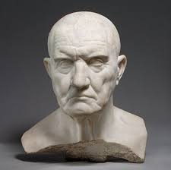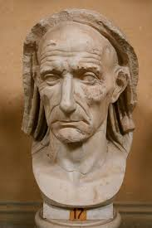
Romans used realism and showed warts and all
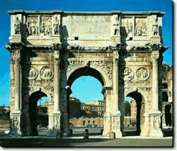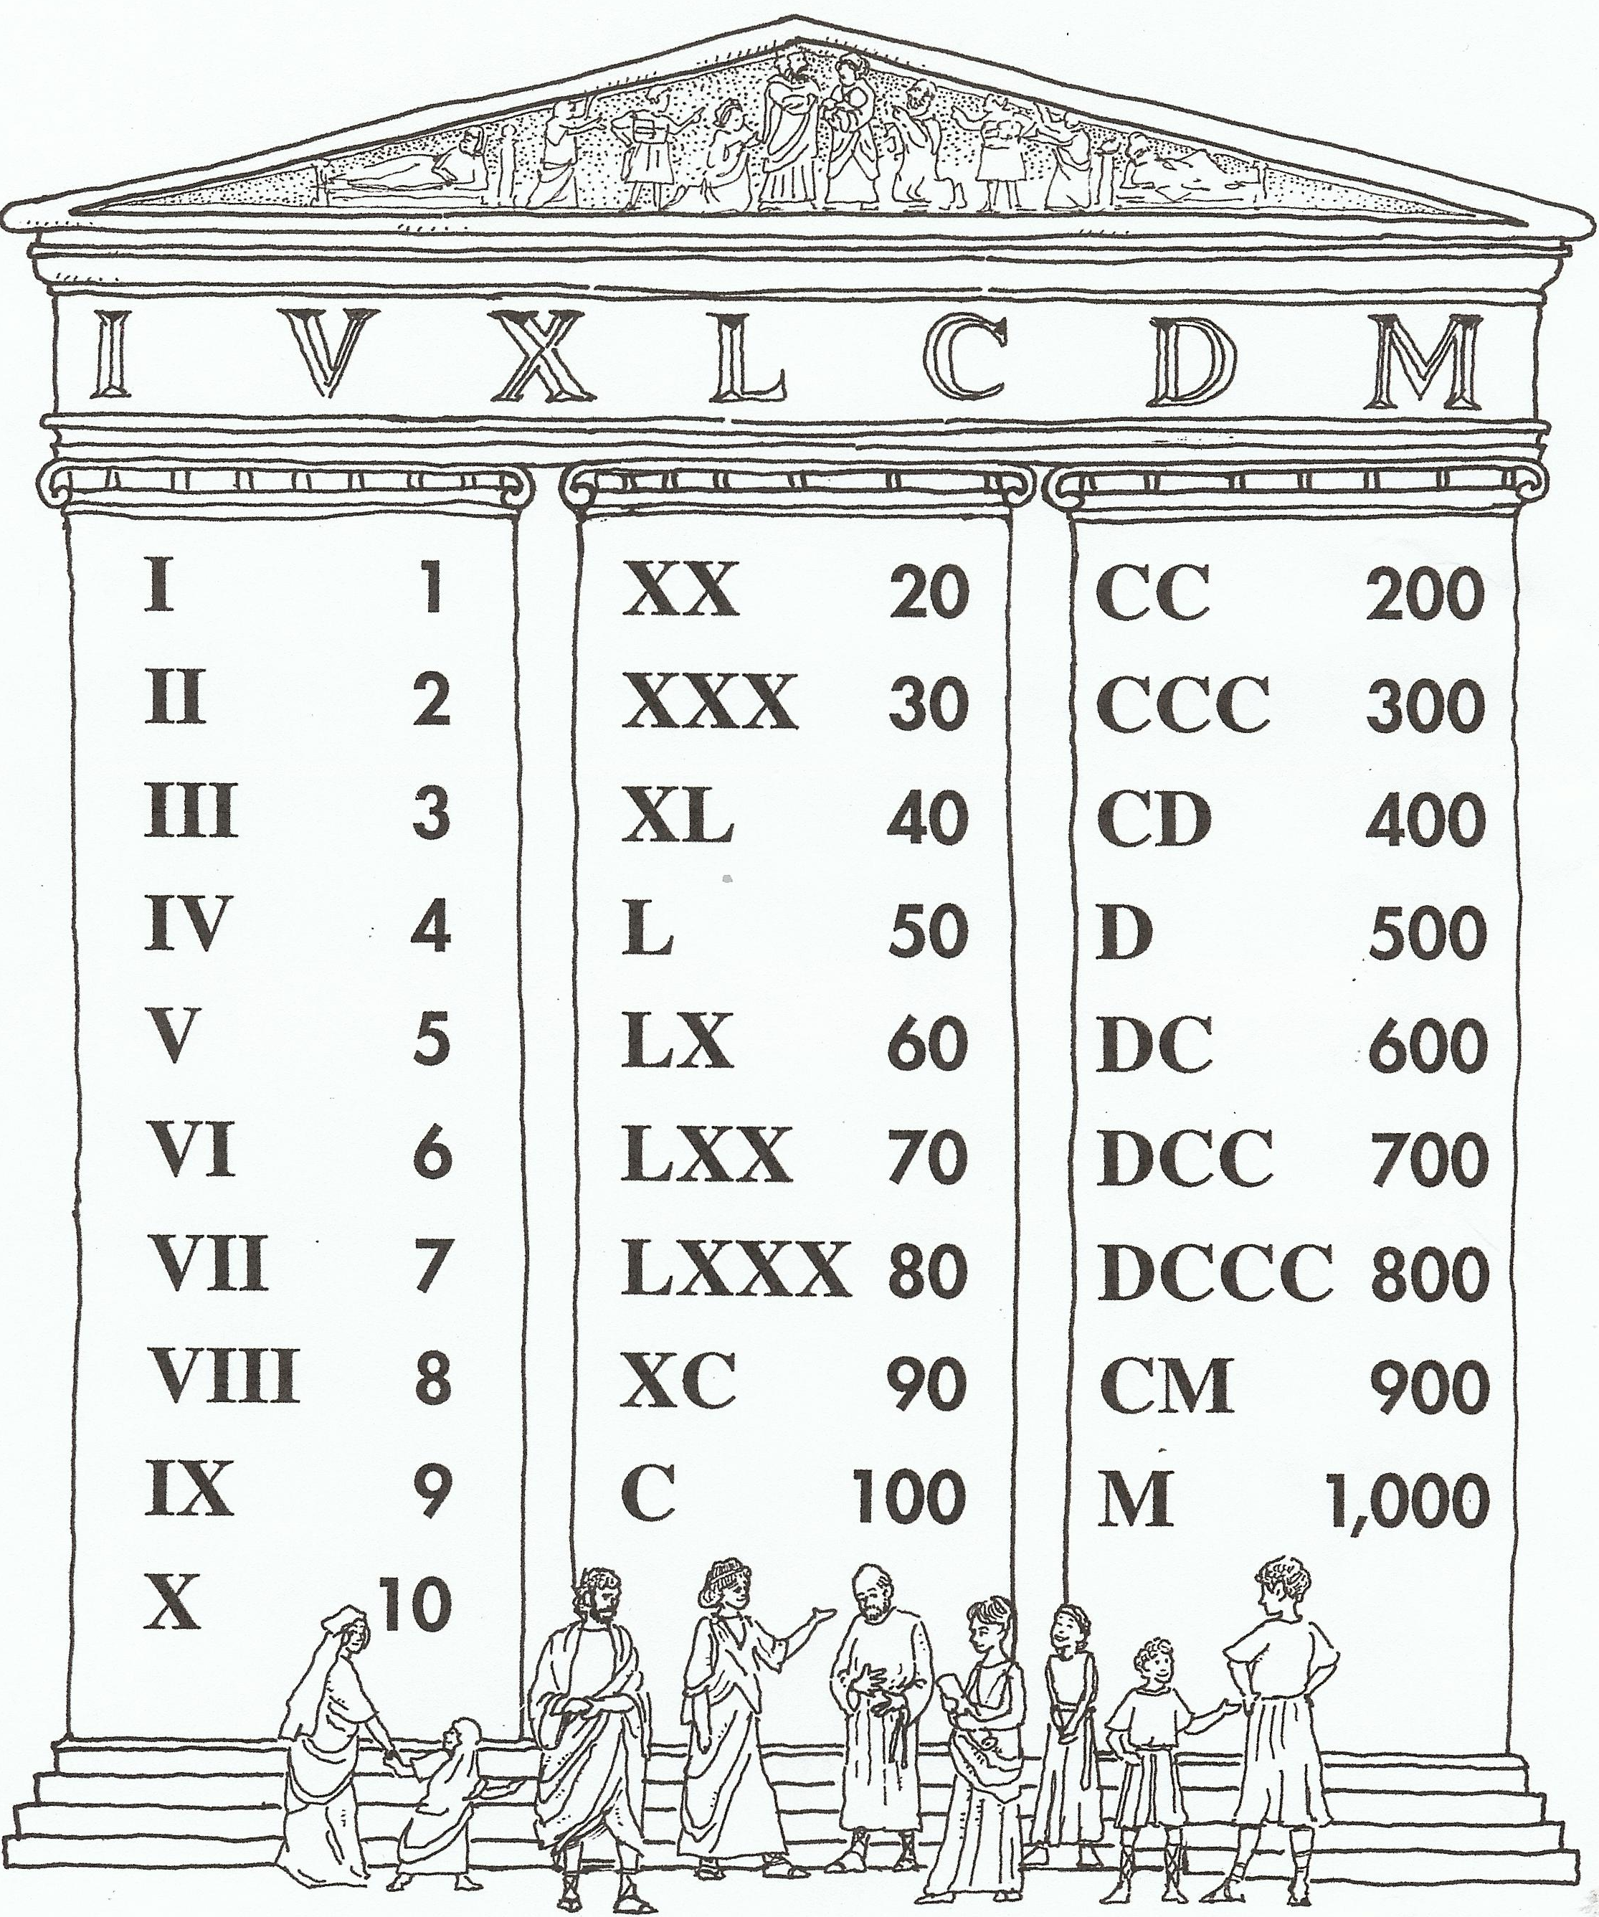
The Romans were the first to use the arch on a massive level

Roman Slavery
- Roman emperor at top
- Roman society dominated by an elite class of wealthy families (pater familias)
  - Male heads of families dominated decisions within the family
  - Increasing wealth and power in a new class of merchants, landowners, & builders
- Growing poor classes increasing as a problem
- Roman society made extensive use of slave labor (as much as 1/3 of population of empire)
  - Rural slaves
    - Some worked on farms/plantations of the wealthy in countryside
    - Many labored in state quarries and mines
    - Rural slaves worked under extremely harsh conditions (often chained together)
    - Discontent among rural slaves led to many massive revolts (Spartacus)
  - Urban slaves
    - Female slaves commonly worked as domestic servants
    - Males toiled as servants, laborers, craftsmen, shopkeepers, or business agents for their owners
    - Slaves who had an education could lead comfortable lives
    - Urban slaves could hope for manumission (freedom) after long years of service
  - Owners had strict authority over slaves
    - Right to sell them, arrange family affairs, punish them, & even execute them

Rome and The Han Dynasty in China

The Roman Military and Roads allowed the transfer of ideas.

