World History #12
Rome Republic

Birth of Rome or
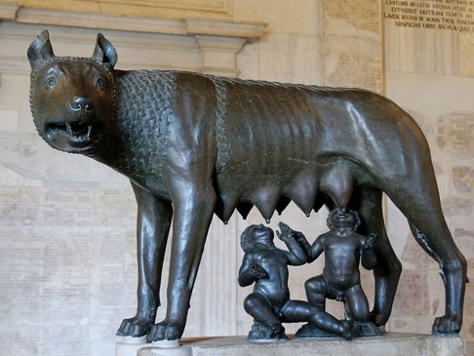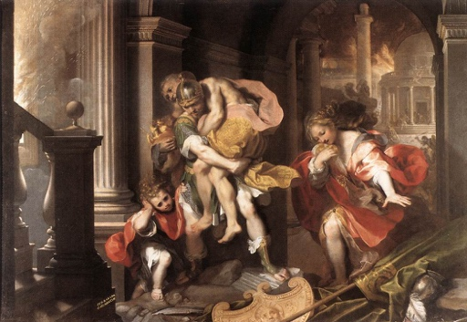
Romulus and Remus raised by a she wolf Aeneas escaped Troy with family

Rome Republic
Senate – 12 Tablets – Civil Law for Romans / Common Law all others in Empire
Patricians (puh-TRISH-uns) ruled the city and the plebeians (plih-BEE-unz) left the city. Later when the city was under attack the patricians beg the plebeians to return. The agreement was that the plebeians would get two Tribunes who call a Veto – “I forbid it!”
Dictator was place in power in emergency for six months and Cincinnatus was dictator and given the power. He ended the emergency and gave back the power.
Rule of Law
Cicero (SIS-er-oh) Liberty protected in hands of people
Rome built:
14 aqueducts into Rome
Had flush toilets and hot water
50,000 miles of roads
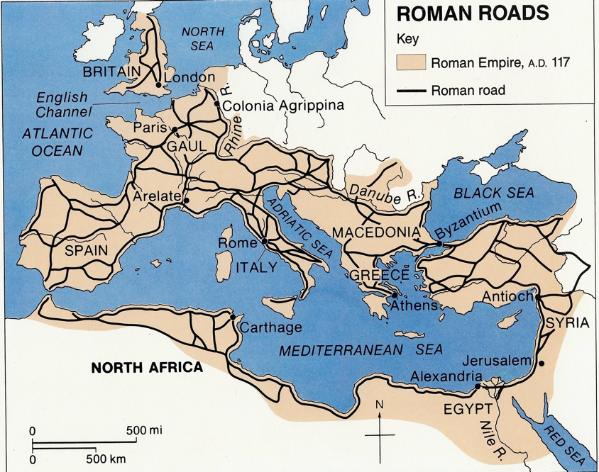
Used the Arch in construction
Used Lead pipes
Cement allowed faster construction
Romanesque architecture thick walls at base as one went up
Military - order and organization – citizen soldiers
Science in battle - each man fought for 12-minutes then stepped back
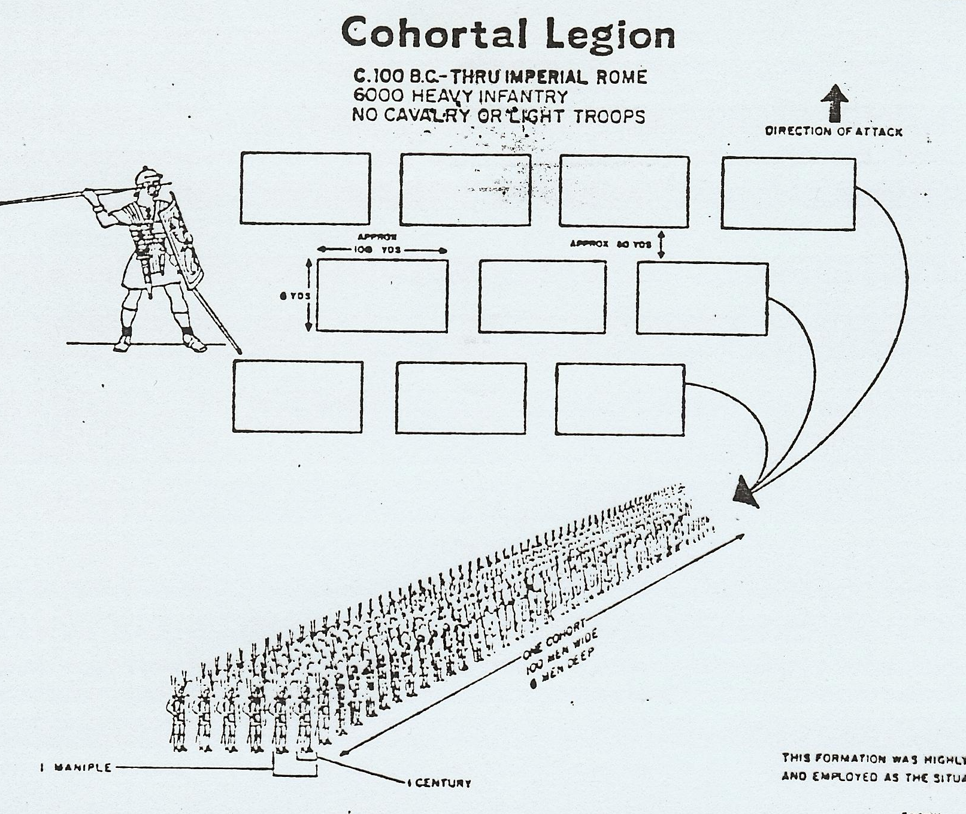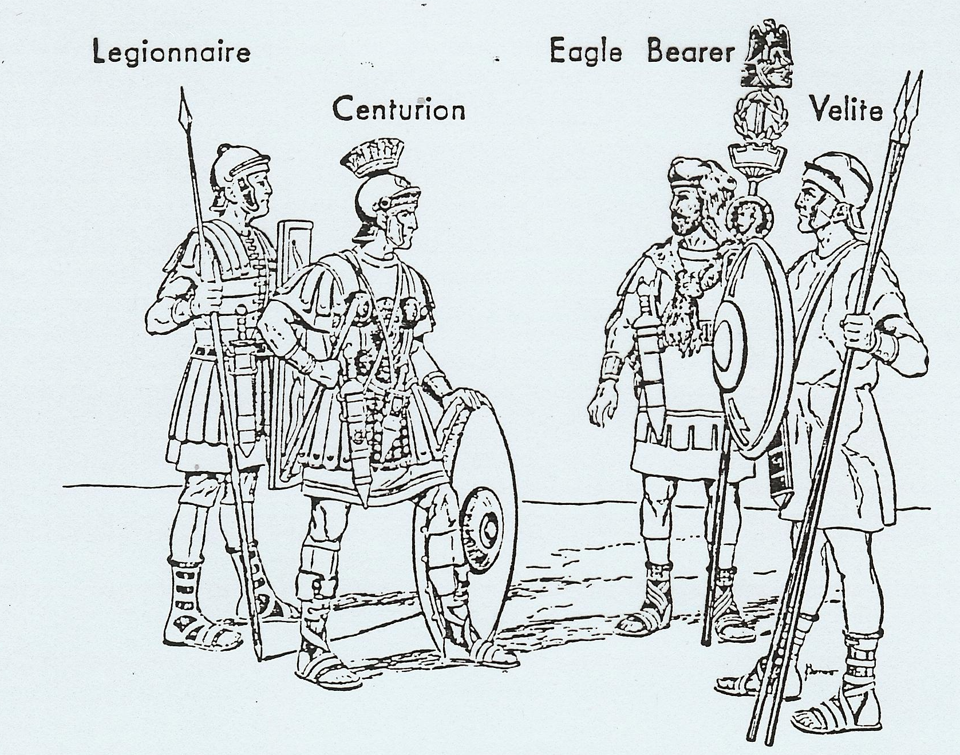
Short sword for jabbing and stabbing
Spears made to bend after throwing
70 pounds carried on March
Camp built each night
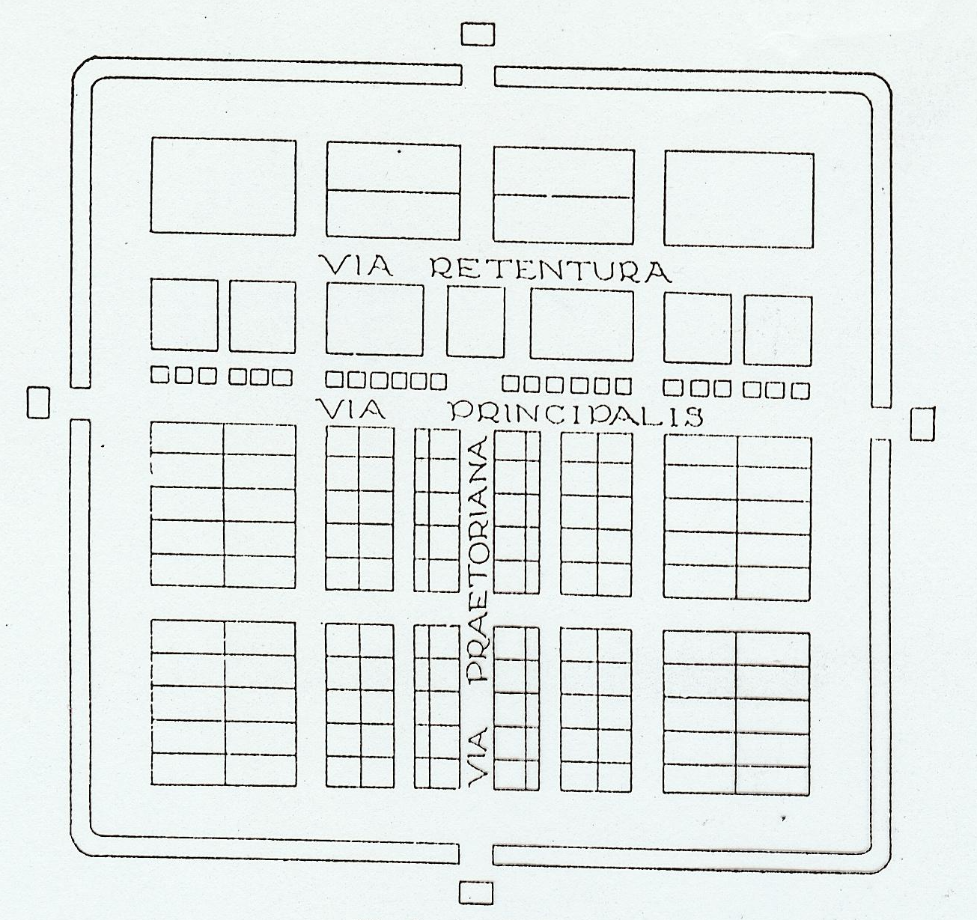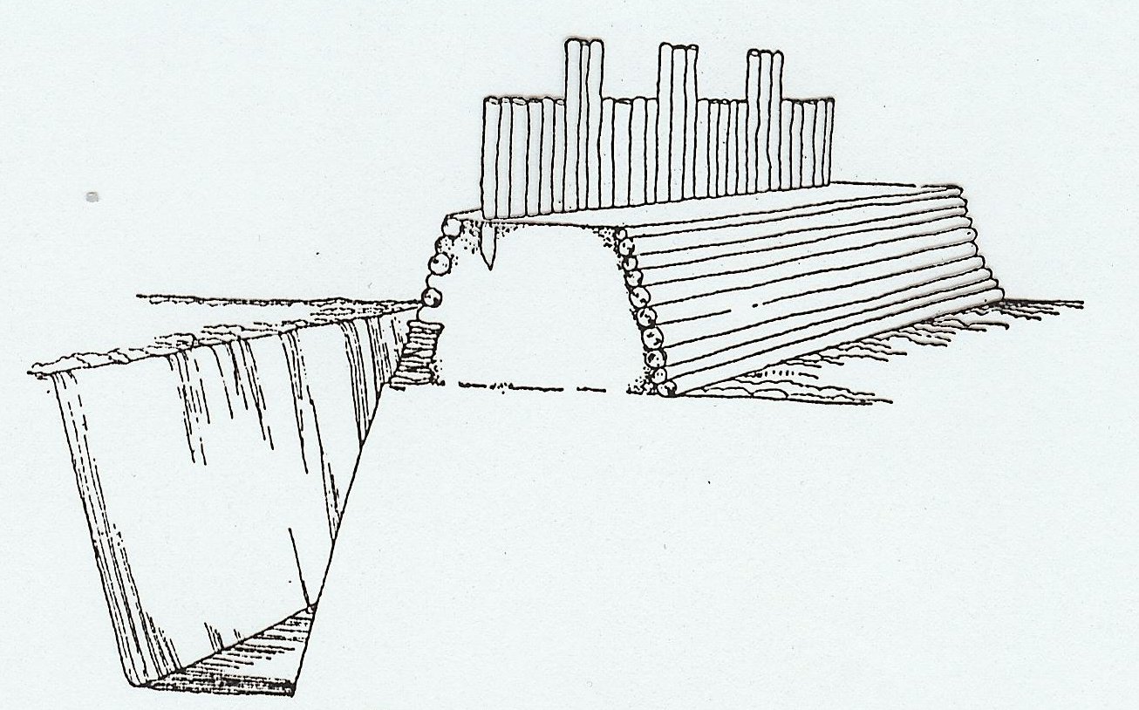
Camp Palisade and Ditch

Punic Wars
Carthage - Hannibal took the war to Rome by crossing the Alps. He started
with 40,000 infantry, 6,000 cavalry & 60 elephants and ended with 26,000
infantry, 4,000 cavalry & 20 elephants. He was never defeated in Rome.
Hannibal used every advantage – weather, terrain, psychology & ambush
Scipio won at Carthage

217 B.C. Battle of Callicula Pass – used sticks tied to horns of cows then set on fire – slip pass
Romans trap
216 B.C. Battle of Cannae - sagging center - 70,000 Romans killed – trap
202 B.C. Battle of Zuma
