World History #10
The Achaeans

The gods and goddesses lived on Mount Olympus and acted in everyday human life. Zeus removed his father Cronus to become the head god of the pantheon.
The area that is called Greece is islands and peninsulas with poor land for farming grains. Olives became a major crop along with goats and sheep. The Achaeans became skilled seamen.
The early empire expanded around cities and one of these was Troy. Troy was known for its horses and wealth. Homer told the story of Troy and its war with the Greeks around 1200 B.C.E. in the Iliad. King Priam and his sons Prince Hector and Prince Paris ruled the city.
Greeks goddess planed a party and could not decide which one was the most beautiful goddess to be given the golden apple. They turned to Paris and asked him to judge the most beautiful. He was then promised bribed with each goddess offering something different. Aphrodite promised him the most beautiful woman in the world and she won.
Problem was the most beautiful woman was Helen the wife of King Menelaus of Sparta. The two ran off to Troy. Menelaus asked Agamemnon King of Mycenae and other to go with him to get his wife. The wealth of Troy played a major part in the agreement to go. Before the left Achilles was asked to join the war. Achilles had dunked Achilles in the River Styx to give him protection with all but his heel placed in the river.
During the war there was an argument over a captive woman that Achilles claimed was his. Agamemnon refused to send Chryseis back – god’s punished then with a plague. Agamemnon sent her back but demand Briseis from Achilles – after doing it.
Achilles refuse to continue in the fighting and sat in his tent. When Hector called Achilles out Patroclus his best ‘friend’ then disguised himself as Achilles and went to battle and was killed by Hector.
Achilles demanded revenge and killed Hector in battle. The body was then dragged around the city and then tossed on a heap of garbage.
The gods stepped in once more and Paris shot an arrow that hit Achilles in the heel killing him. The war lasted ten years and no victory.
Trojan Horse idea came from Odysseus (Ulysses - Latin) and the war ended in a Greek victory.
Homer then told the story of Odyssey journey home another ten years.
Homer's - Iliad and Odyssey - Achilles - Hector - Ulysses

Troy and defeat Achilles battle Hector
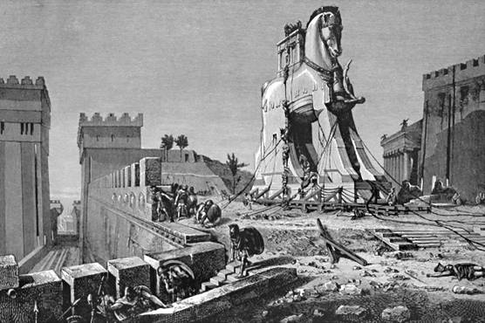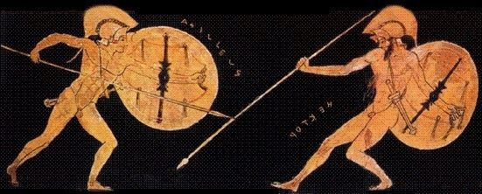

Theseus (the Thinker) Hercules (the strong)
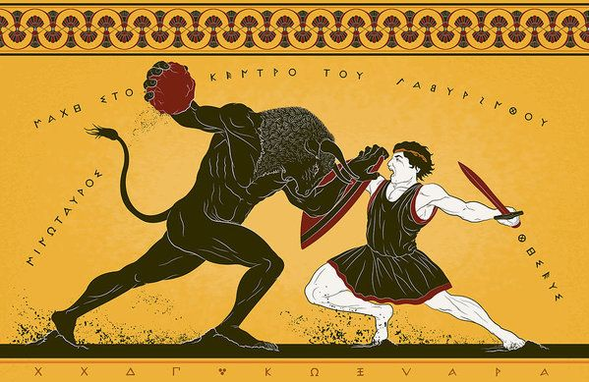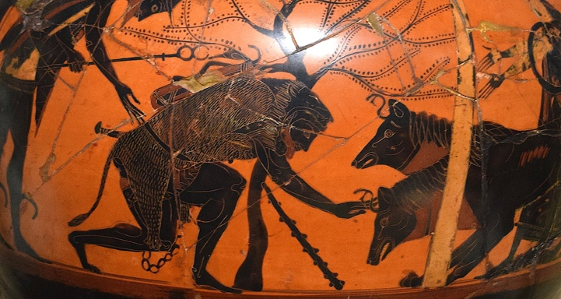

Classical Dark Ages 1100-750 B.C.
Collapse of Empires by people from the sea.

Mycenaeans and Minoans
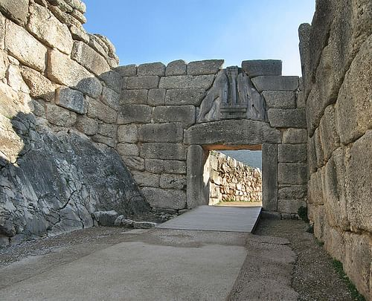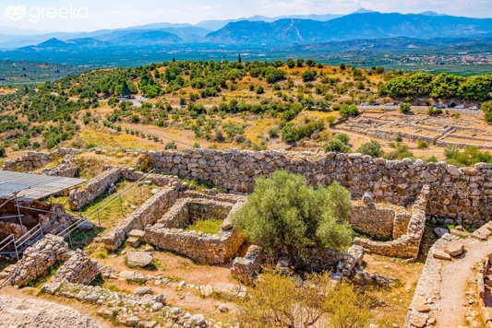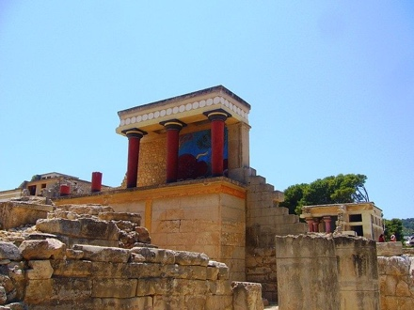

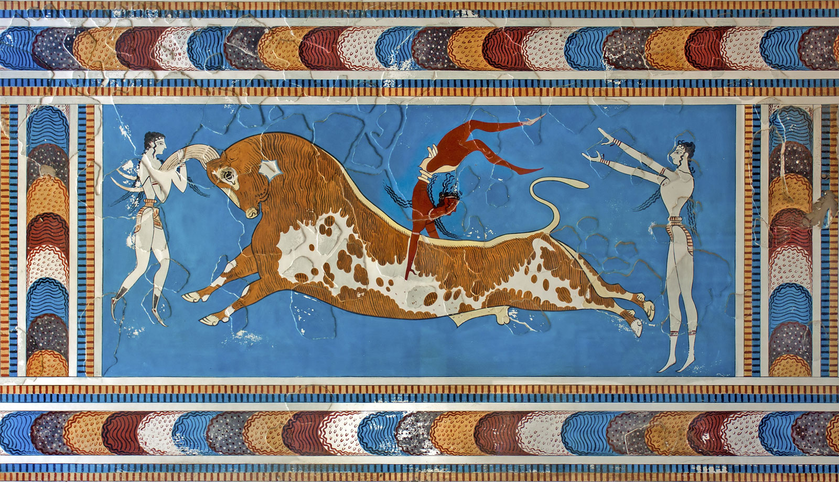

Greek Art Showed perfection or beauty
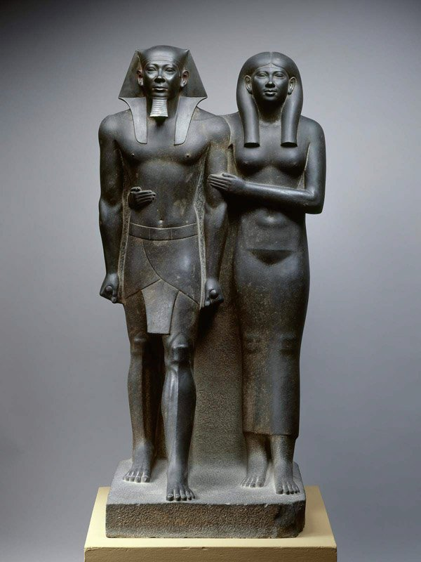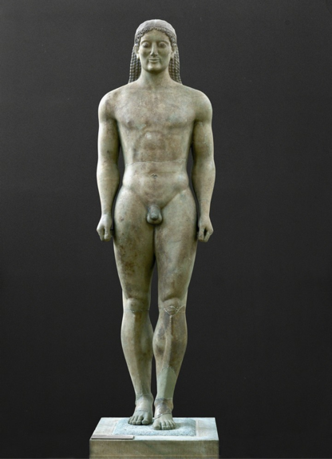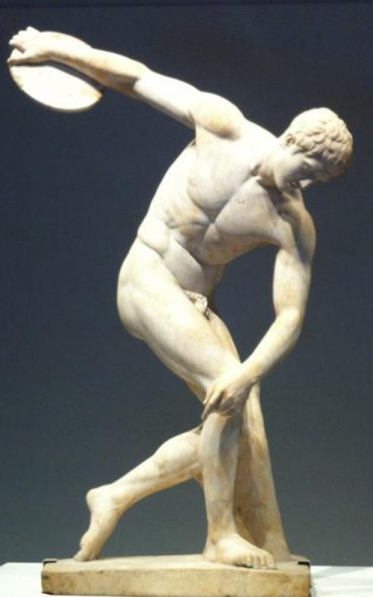
Egyptian Art Early Greek Later Greek

