Lesson Outline #1 World History
Pre-History to 10,000 B.C.

Time Line: : 3.8 million B.C. - first man? “Lucy”
2.0 million B.C. - first house (windbreak)
1.5 million B.C. - man out of Africa?
500,000 B.C. - man first used fire?
70,000 B.C. - start of last Ice Age
35,000 B.C. - needle developed
30,000 B.C. - Land Bridge to North America open
10,000 B.C. - Wisconsin Glacier Age (Last Ice Age) ends
- Geography
- Earth and Solar System
- 1. Solar system
- a. Milky Way – 100,000 light years across/16 light years thick
- b. Sun – takes 9 minutes for light to reach earth hits at 60-degree angle
- speed of light is 186,300 miles per second
- c. Earth
- 1. tilt – 23 and1/2 degrees – (Four Seasons)
- 2. currents – Clockwise in the Northern Hemisphere / Counter in South
- 3. Atmosphere
- a. 21% oxygen
- b. 78% nitrogen
- c. Pole’s warm the earth
- d. Equator cool’s the earth
- d. 93,000,000 miles from Sun
- e. 24,902 miles circumference at equator/24,960 miles at poles
- f. Mythology and terms still used today
- g. Ptolemy, Copernicus, and Kepler – position of Earth in Solar System
2. Speed of travel and movement in solar system (3 direction at same time)
a. spin = 1,000 mph (24 hours)
23 hours, 56 minutes, 4.09 seconds
b. revolving = 66,600 mph (365 days)
365 days, 6 hours, 9 minutes, 9.54 seconds
c. traveling = 43,000 mph through galaxy
d. Coriolis effect plus Thermal Effect = causing currents
e. Slower in March than in September
- Layers of Earth
a. core = 9,000 degrees (nickel and iron) rising and falling in core
b. mantle = 4,000 degrees – magma / rise and falling
c. crust = 1,000 degrees – The outer surface of earth that floats on
mantle pulled apart & pushed together (Plates)
- Climate
- Terms
- Solstice – Summer
- Equinox – Spring
- Oceans, and Continents
- Atlantic, Pacific, Indian, and Arctic
- Africa, Asia, Australia, Antarctica, N. & S. America and Europe
- Environment
- Water Cycle
- Life Cycle
- Weather
- Global Grid System
- Hemispheres – earth in half sections
- longitude (meridian) lines (Pole to Pole - 90 degrees)
- latitude (parallel) lines (around – 360dregrees)
- Cardinal directions (N/S/E/W)
- co-ordinates and time zones (24 each in 15 degrees))
- Land Forms
1. mountains – 6,000 feet / hills – less than 6,000 feet
2. forest and jungle
3. desert – less than 10 inches of rain per year
4. tundra – frozen ground
5. steppes – short grass in inches
6. prairie – tall grass 4-10 feet
7. rocks
- Igneous = molten rock
- Sedimentary = layered rock
- Metamorphic = changed by heat and pressure
- Diamonds are made 100 miles deep in neck if volcanoes
Brazilian diamonds are harder than African diamonds
e. Gravity is .07% different from West to East coast – mass in West
- Political and Physical Maps
- Pre-History (time before written records)
- Physical Anthropology
- Man vs. Ape (natural selection – (evolution is a local event with no
direction)
- Blood types
- “O” is the oldest
- “A” rarely found in New World or Australians
(Blackfoot or Blackfeet Nation)
- “B” not found in New World (highest distribution in Himalayas)
- “A/B” rarely found above 50%
- Bone and teeth
- Skin –
1. dark skin allows - 3% of Sun absorption for vitamin “D”
2. light skin allows - 53-73 % of Sun absorption for vitamin “D”
- Eyes
- blue – most sensitive to light
- dark – dark brown lest sensitive
- sight is 90-95% of human sensory perception
- Nose –
1. wide round nostrils – allow hot air to cool before entering the lungs
2. narrow small nostrils – allows cold air to warm before entering
Entering the lungs
- Hair – lost cooling effect – sweat glands
1. Long hair warming
2. tight curl hair cooling effect (insulation effect)
- Posture
- biped
- lose 1/3 more body heat
- voice
- vision
2. Premature birth -Gravity (human babies depend on mother)
h. Body size
- thin – cooling effect
- large – warming effect
2. Cultural factors
a. Idea of body beauty will shape size
b. Idea of body to enhancement or detract (art)
- Man unique (22 + x and y)
A. Superior nervous system
B. Vision – stereo and in color
C. Manipulated thumb
D. Biped (stand on two legs)
E. Brain shift – a shift to right side of brain for dominant in thinking process
F. Tools and games?
1. one time man was believed to be the only one to make tools
2. that proved to be wrong in a number of areas
3. the same happen with games
- Pangea (Super Continent) and Continental Drift Theory
A. Continents fit together
B. Old rock match old rock and new rocks match new rocks when fit together
C. All dinosaur bones match on every continent they are found
D. Earth Quakes and Volcanoes at edges of plates
E. Africa’s five empty basins were once super lakes
F. African rivers had flowed into the lakes now they make U-turns they
flow outward today
G. Africa is still being pulled apart at Great Riff Valley
H. Differentness in animals and plants
1. Old World animals are larger
2. New world monkeys have a prehensile tail – old world do not
3. Australia wild life unique

- Geography and the Five Themes:
A. Location – Where is it?
B. Place – What does it look like?
C. Interaction – How do they relate?
D. Movement – How do ideas and people travel?
E. Region – How are they similar or different?
a. Formal
b. Functional
c. Perceptual
d. Psychological

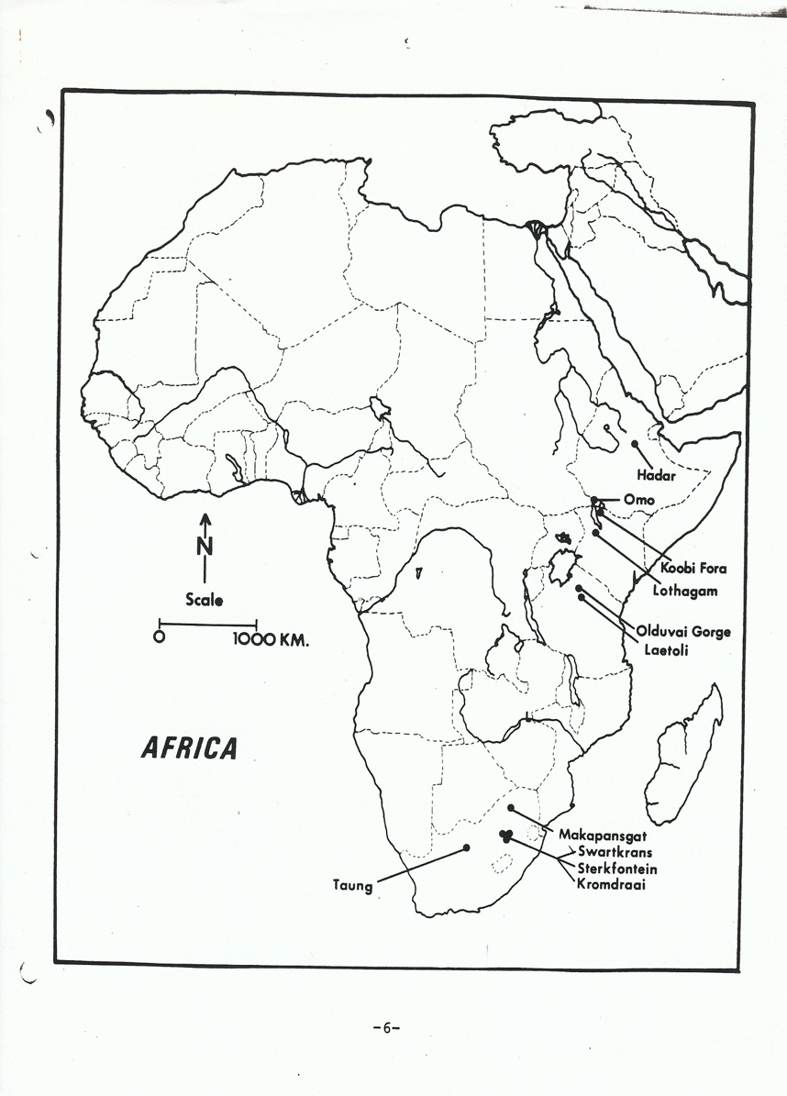

AFRICA TODAY
* Is a high plateau with slight tilt and an absence of mountains
* It has the coast line with 2/3 with escapements (cliffs)
* Great Riff Valley – long narrow lakes
* Five great empty basins down deserts
* Rivers flow into the interior then U-turn out – except the Nile that flows north

* Sub-Sahara that part of Africa below the Sahara Desert
* The word Sahara is Arabic for desert – there are about 90 Oases in the Sahara
* Desertification – expanding each year
* Savannas (suh-VAN-uhz) grass plains
* Rain Forest – jungle

The tropic are filled with life forms and Africa has the largest land mass at the Equator
Insects
Tsetse Fly – host to parasites (Sleeping Sickness)
Mosquitoes
Diseases
Malaria
Sickle Cell – mutated red blood cell carries less oxygen – protects from Malaria
However the mutation is painful and deadly

* The escarpment, deserts and insects were major reasons for Africa to be called known the
Dark Continent until the 19th century - other continents had less obstacles to overcome.

* European colonialism divided the continent on geographic lines and not tribal lines.
Today the tribal conflict is in part trying to reestablish tribal authority and geographic
territory.

